1. Installing and configuring Eclipse and tomcat.
   1. reason for using tomcat installation in server location is : it uses the same catalina propertis of tomcat
   2. 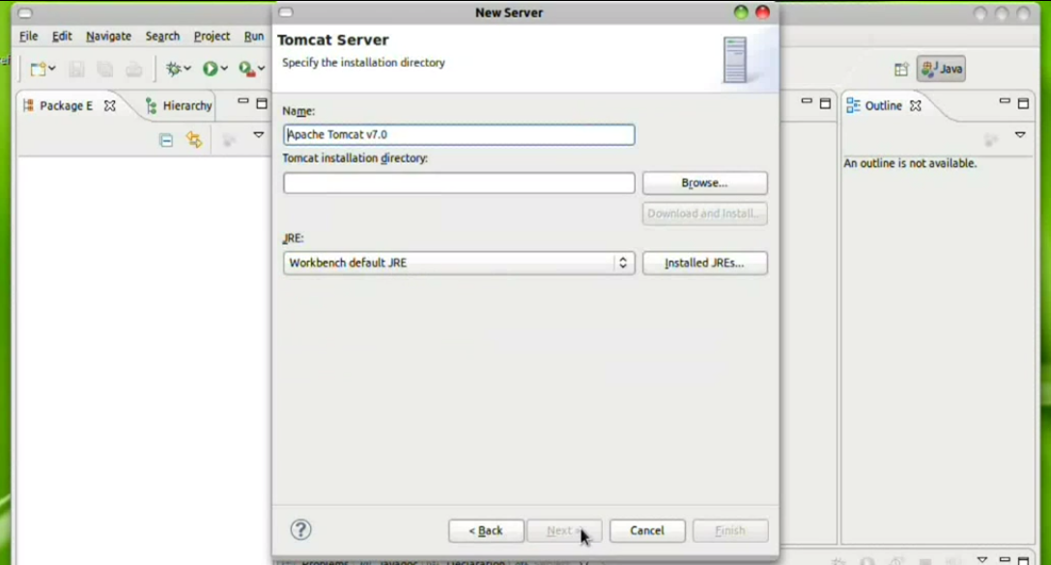
   3. Set up the Tomcat 7.0
2. create a sample proj.
   1. Create a dynamic web application
   2. 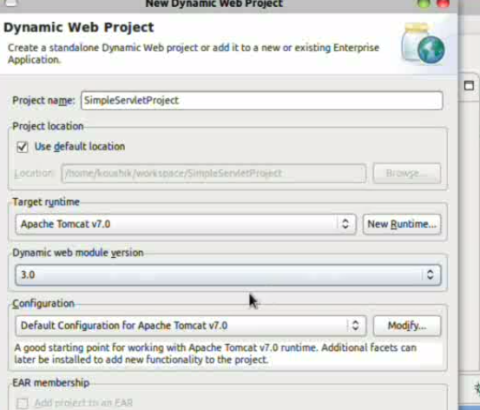
   3. Open web.xml. Create a sample index page and deploy the application.
3. Create a servlet.with do get method
   1. Create a new servlet.
   2. 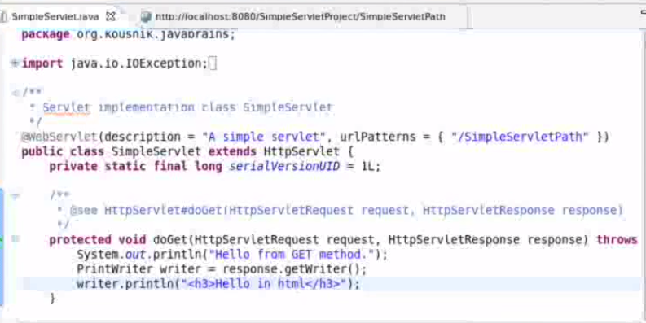
   3. Deploy the application.
4. Working of the servlets (Request, response and how tomcat do with req and res)
   1. 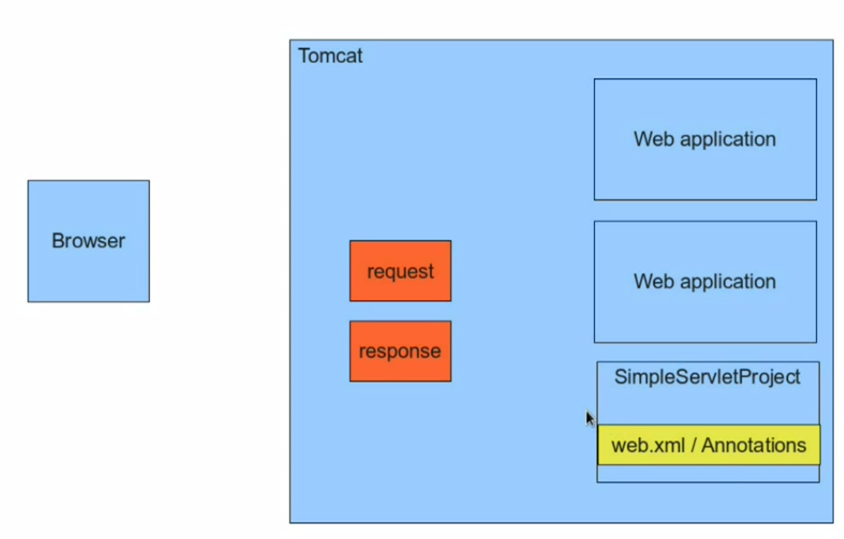
   2. whenever a request is received from the browser, tomcat looks for the exact web application and redirect it the right web application.
   3. 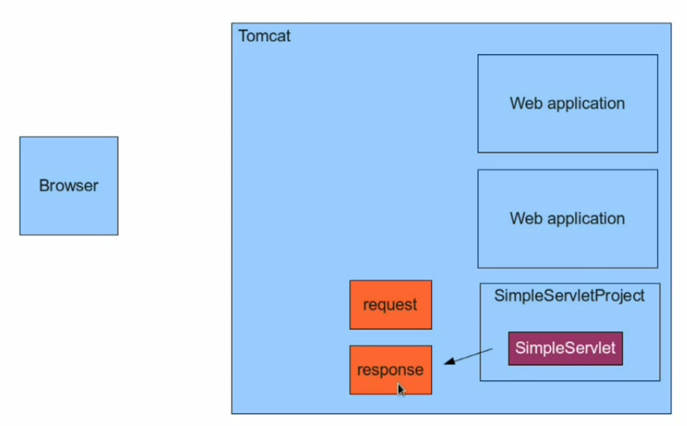
   4. then Servlet project decides the on which servlet to execute.
   5. Now the servlet runs and returns a response object.
   6. This response object is rendered back to the browser.
5. Servlet XML configuration
   1. 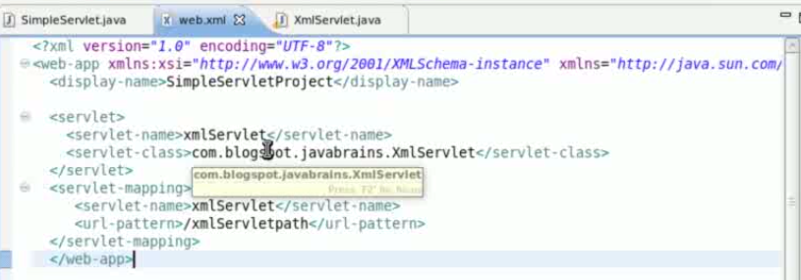
   2. 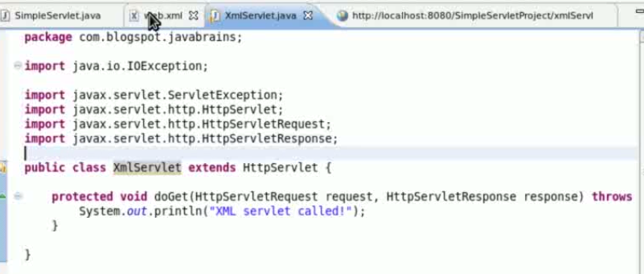
   3. if we use annotation we should compile the application every time when we make any changes.
6. Parameter, Get method and POST method.
   1. 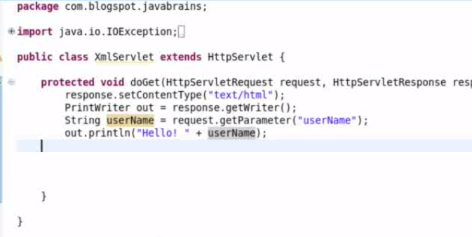
   2. 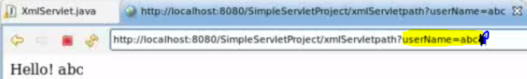
   3. getparameter() - is used to get the value of the parameter
   4. Implementing Post.
   5. 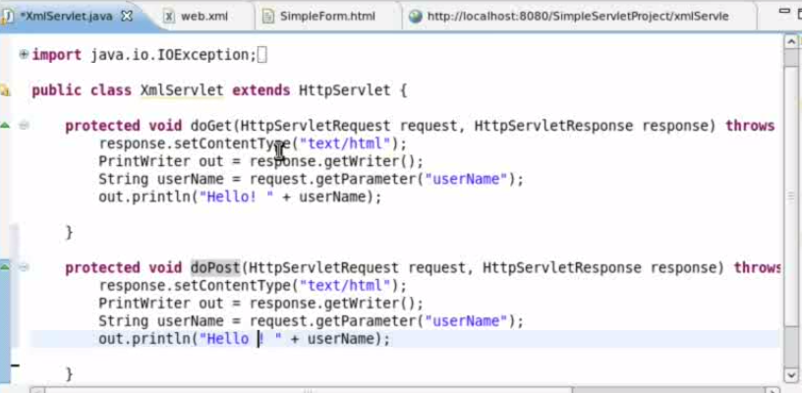
   6. 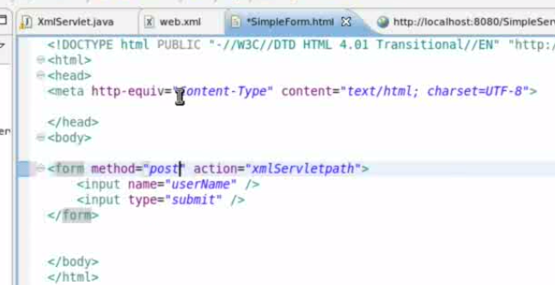
   7. getparametervalues() - is used to get the list of values for a parameter.
7. Parsing more parameters
   1. 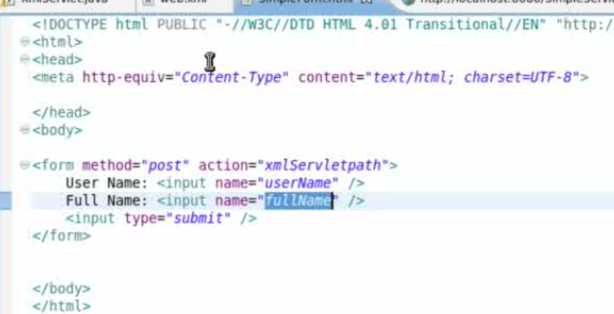
   2. 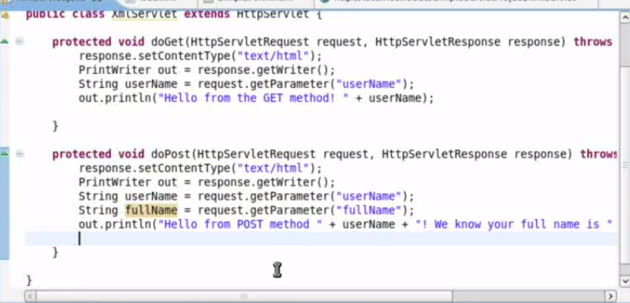
   3. 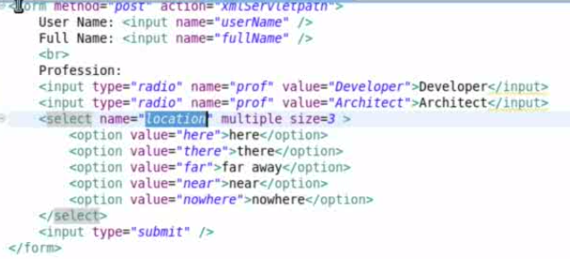
   4. 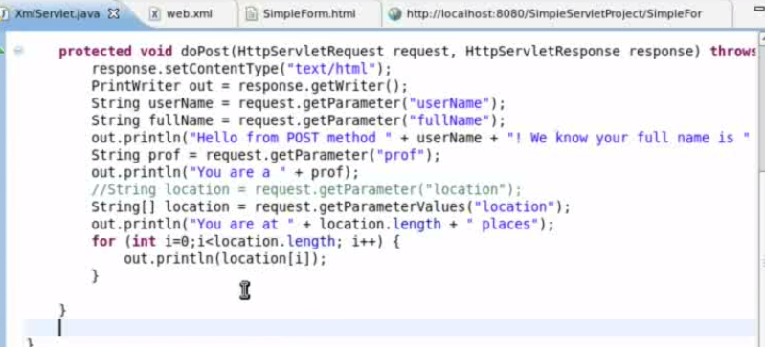
8. Diff bet get and post
   1. On refreshing the browser asks for a confirmation in POST operation only.

|  |  |
| --- | --- |
| **GET** | **POST** |
| The parameter is displayed int the req | Parameter is not displayed in the req |
| This method is used to get the values in the request | This is used to do some data manipulation in servlet |
| On refreshing the browser do not asks for a confirmation | On refreshing the browser asks for a confirmation |
| Maximun Chars transfered is 256 chars | Unlimited data is transfered |

1. Request, Session and context(ServletContext)
   1. 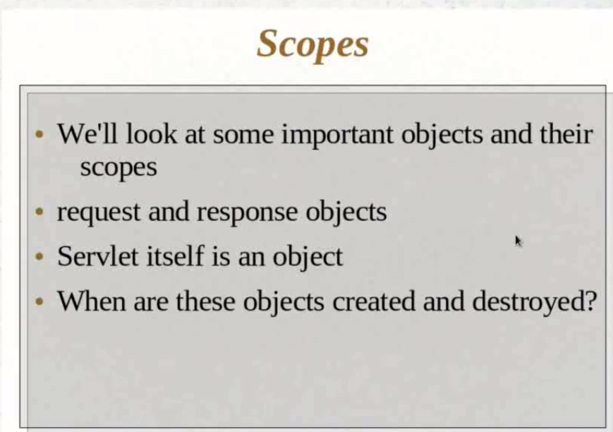
   2. 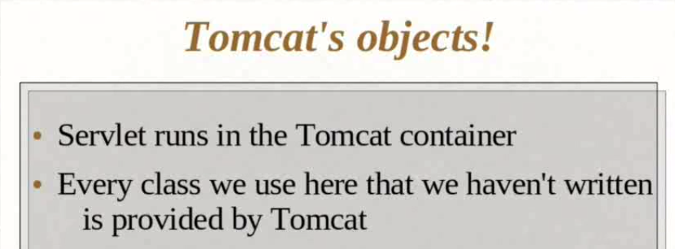
   3. 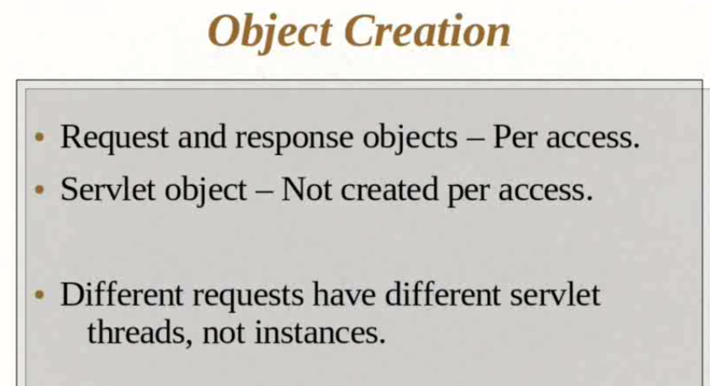
   4. 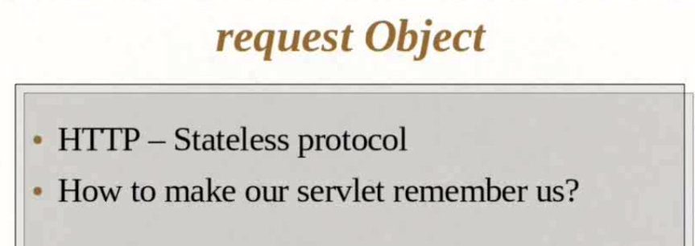
   5. Use Session to retain the state.
   6. 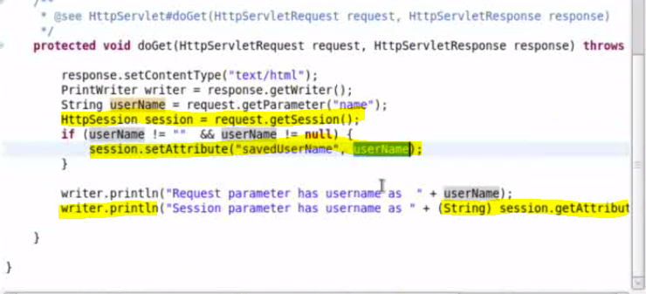

|  |  |  |
| --- | --- | --- |
| Request | Session | Context |
| Values in URL only | Save in session. can not be used when session ends or other browser changes | Remains thru out the application |

1. JSPs and Servlets Tutorial 08 - Request, Session and Context Part 2
   1. 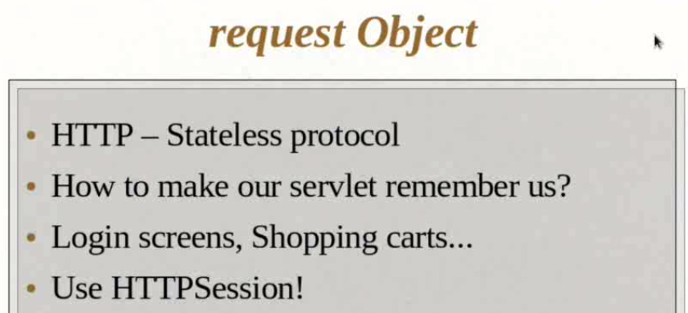
   2. 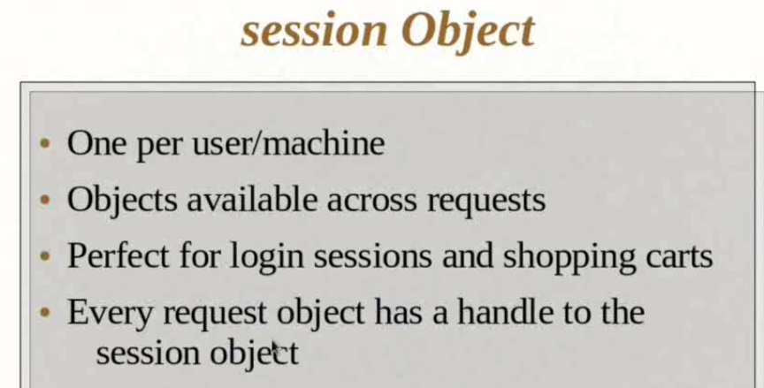
   3. To use objects across different users,
   4. 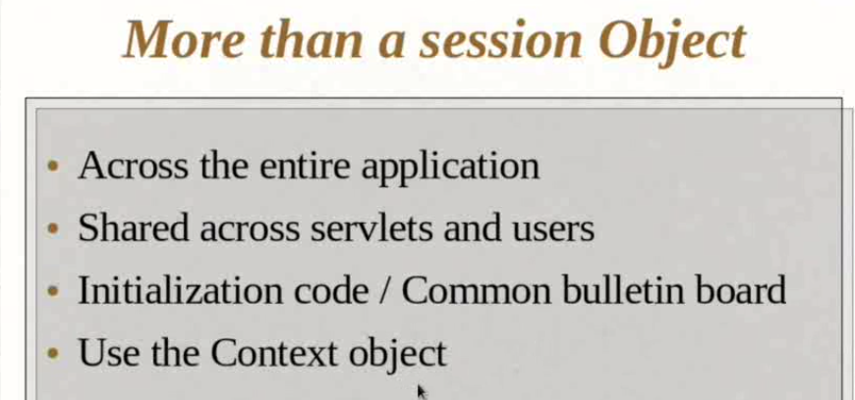
   5. 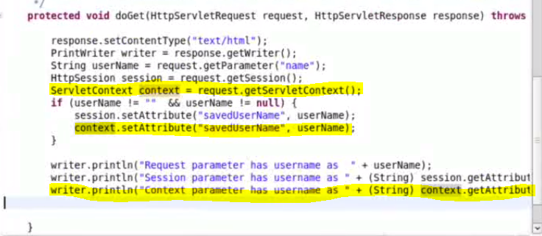
2. JSPs and Servlets Tutorial 09 Part 1- Understanding init, service and ServletConfig
   1. 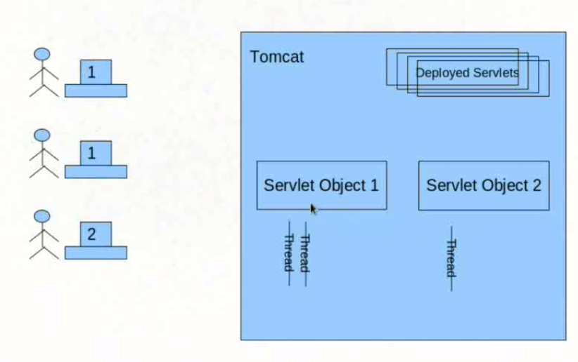
   2. 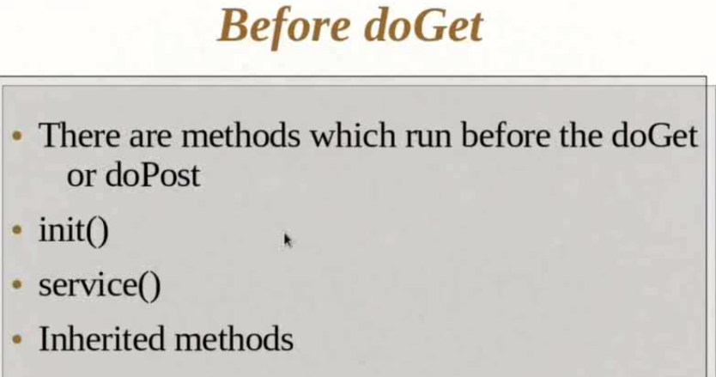
   3. 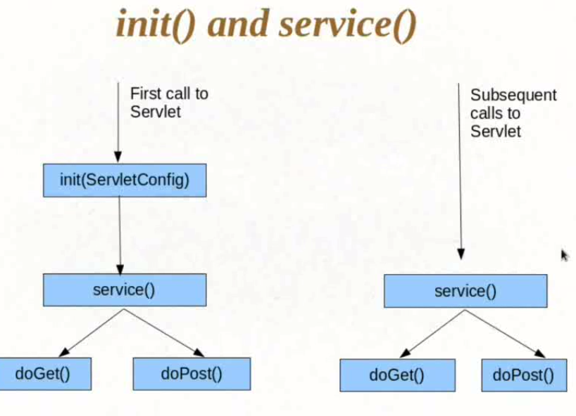
   4. 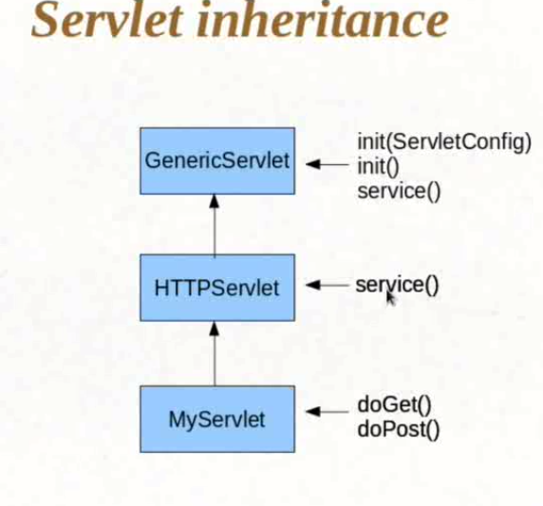
   5. 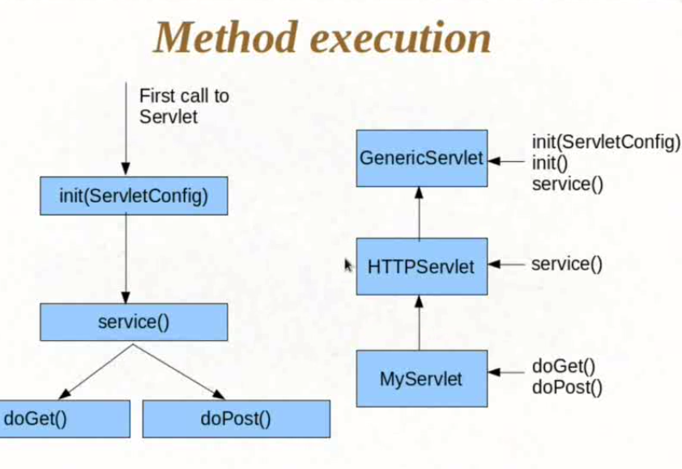
3. JSPs and Servlets Tutorial 09 Part 2- Understanding init, service and ServletConfig
   1. Open HttpServlet Class
4. JSPs and Servlets Tutorial 09 Part 3- Understanding init, service and ServletConfig
   1. For init param in Jsp
   2. 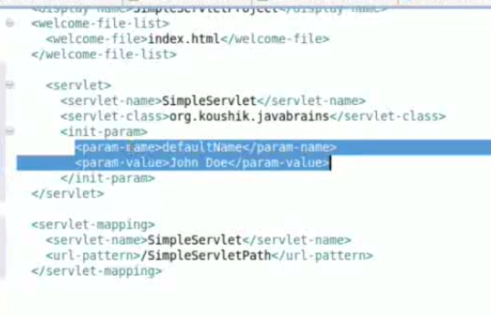
   3. we can also use annotation to do this.
   4. 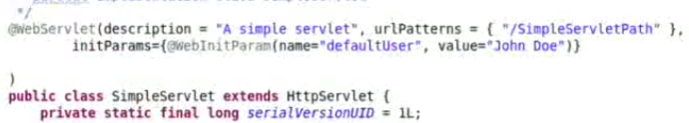
   5. 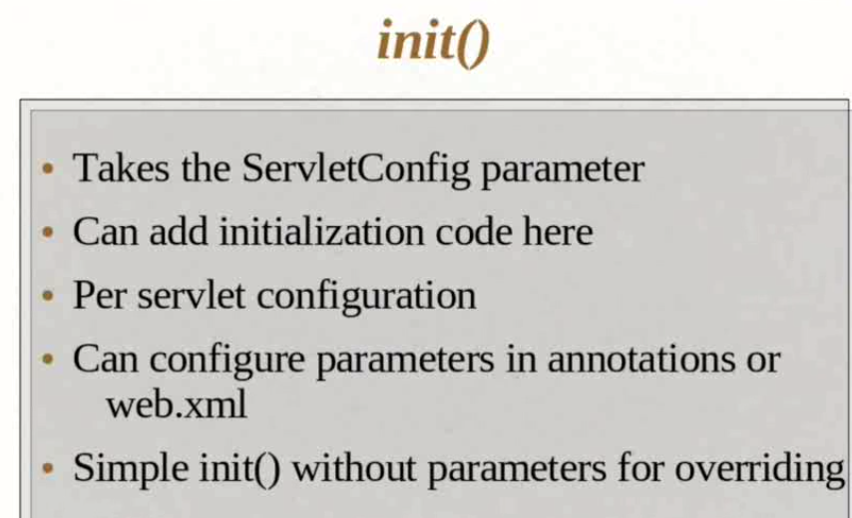
   6. 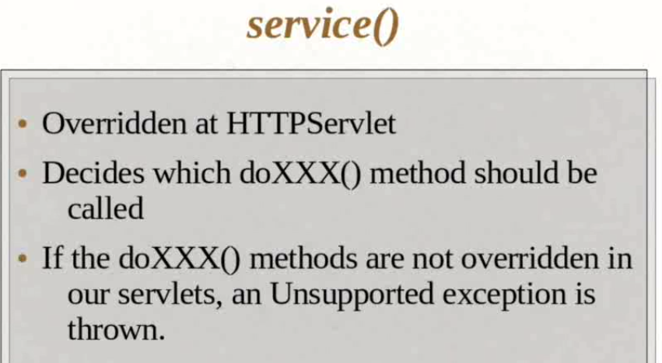
5. JSPs and Servlets Tutorial 10 - Hello JSP
   1. Create a new JSP file.
   2. 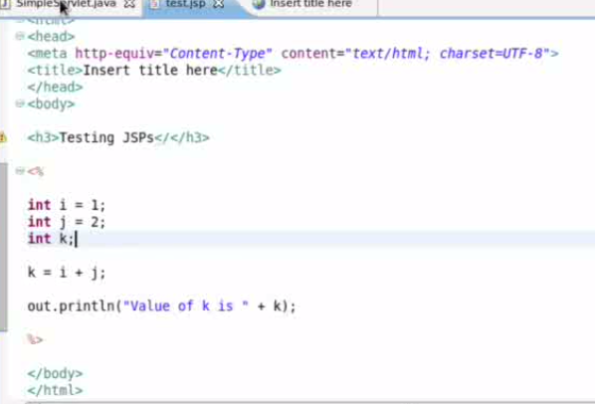
   3. Scriplet Tag - <% Java Code %>
   4. Expresion element - <%= code %>
   5. Delcaration elements - <%! code %>
   6. Comments - <%-- comment --%> <!-- comment -->
6. JSPs and Servlets Tutorial 11 - Understanding the JSP
   1. 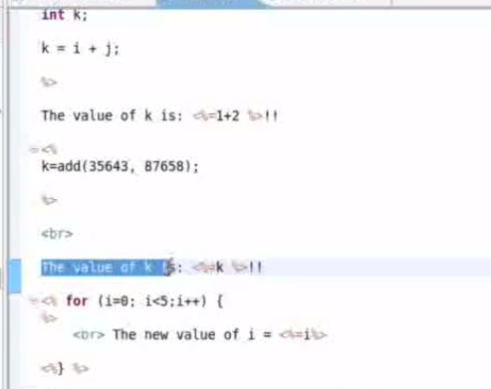
7. JSPs and Servlets Tutorial 12 - JSP Page Directives
   1. 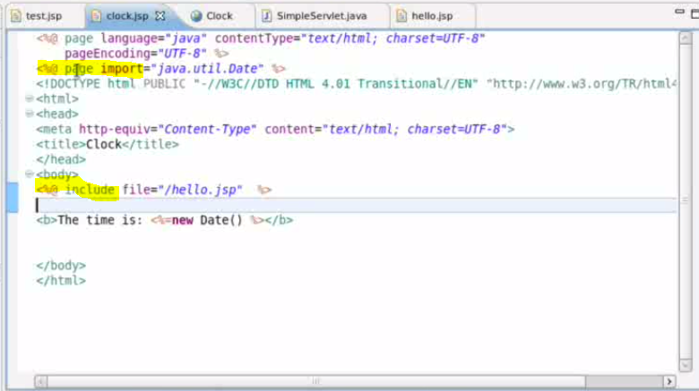
   2. <%@ Page %> Directive is used for header tags
   3. <%@ include %> is used to include a other pages in a JSP page.
8. JSPs and Servlets Tutorial 13 - Scopes in JSP and the PageContext object
   1. 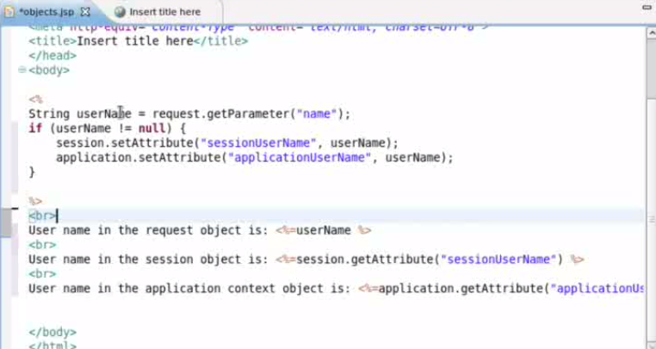
   2. 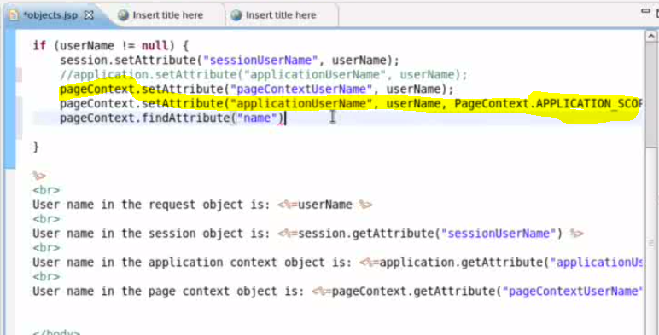
   3. Request, session and Application Context , Page context(Used to set in any of the scope)
9. JSPs and Servlets Tutorial 14 - Using jspInit and InitParams
   1. Configuring in XML file for initparam and Servlet mapping for jsp page
   2. 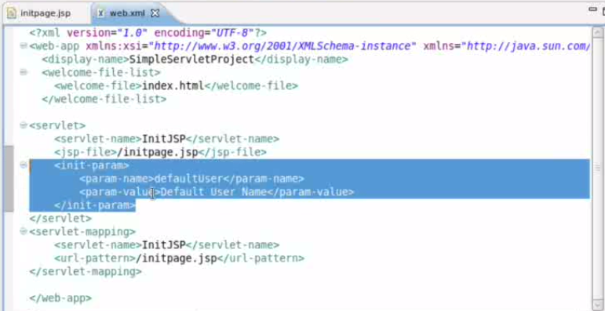
   3. 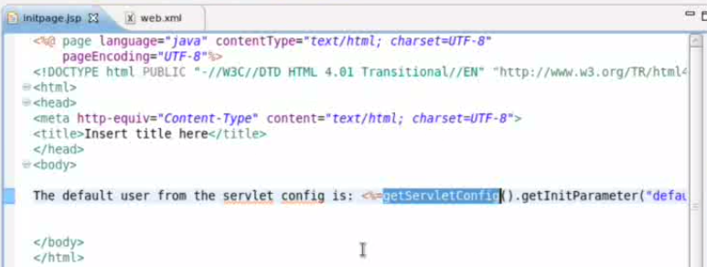
   4. 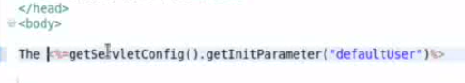
   5. 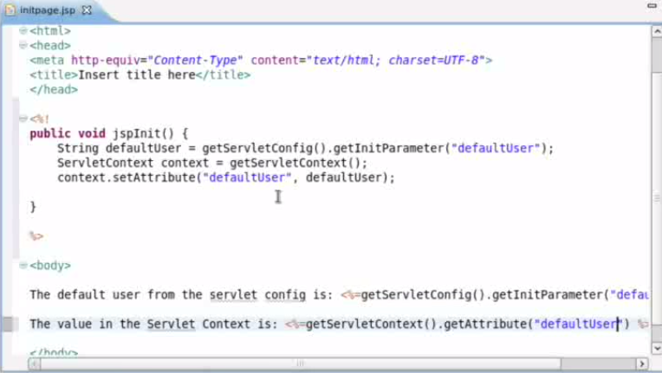
10. JSPs and Servlets Tutorial 15 - Understanding the MVC Pattern
    1. Model - Data
    2. View - Webpages
    3. Controller - Servlet
11. JSPs and Servlets Tutorial 16 Part 1- Writing an MVC Application
    1. 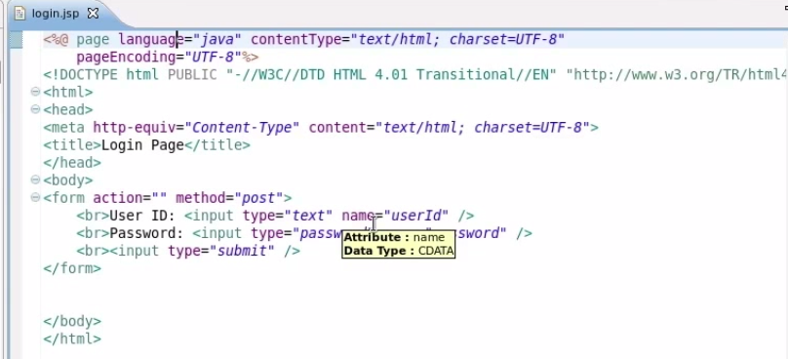
    2. 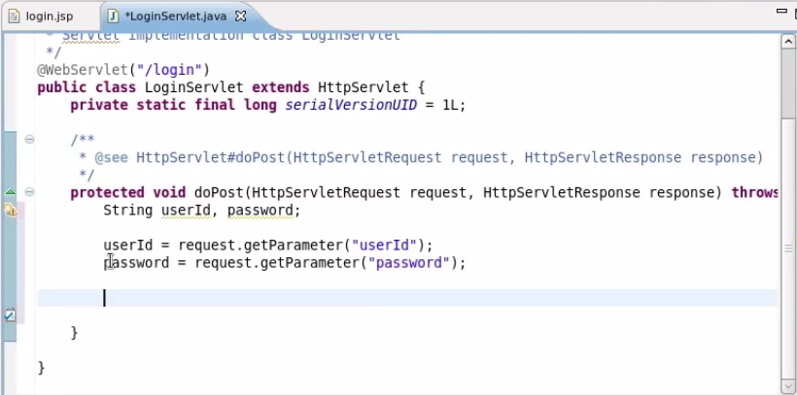
    3. 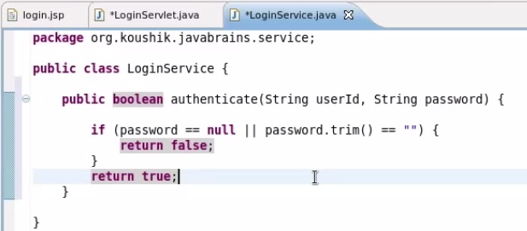
12. JSPs and Servlets Tutorial 16 Part 2- Writing an MVC Application
    1. 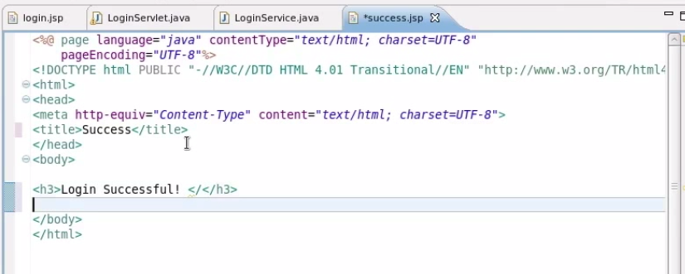
    2. 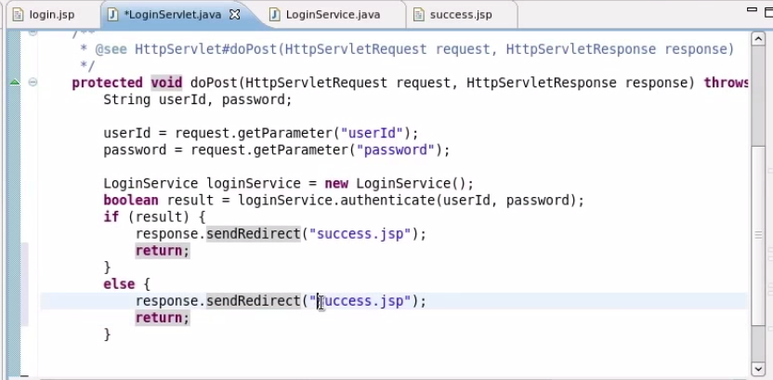
13. JSPs and Servlets Tutorial 16 Part 3- Using Model object in the MVC Application
    1. 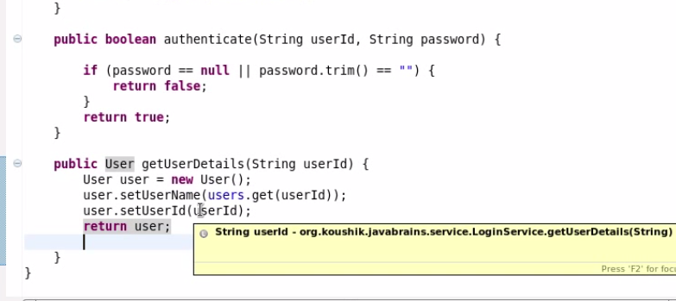
14. JSPs and Servlets Tutorial 16 Part 4- Using RequestDispatcher in the MVC Application
    1. Set user values in session and retrieve in new page
    2. 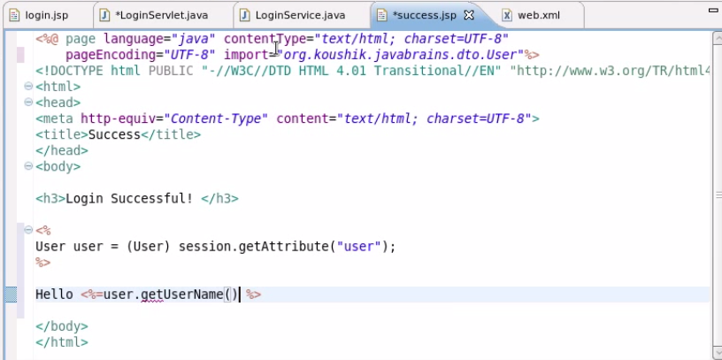
    3. RequestDispatcher - is used to forward the same request to another page
    4. 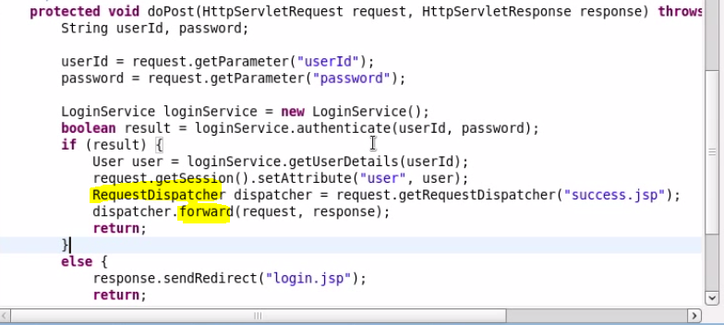
15. JSPs and Servlets Tutorial 17 - Introduction to JSTL and the useBean tag
    1. 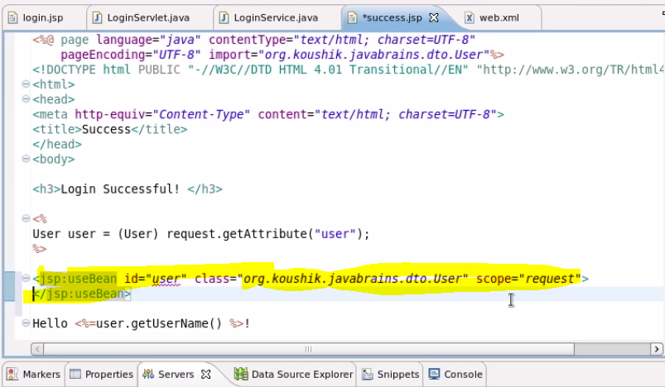
    2. 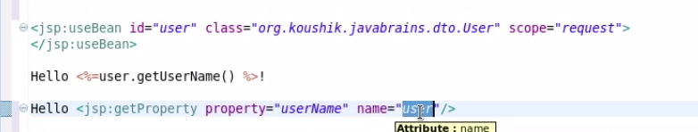
16. get Patameter and GetAttribute in java

# Durga Soft

1. 01.ADV Java Types of Applications using Java
   1. Five types of java applications
      1. stand alone
      2. Server socket program - Client server
      3. Servlets - web application
      4. Enterprise application(between java application) - EJB
      5. Interoperable application - XML and JSON
   2. Servlet architecture
   3. 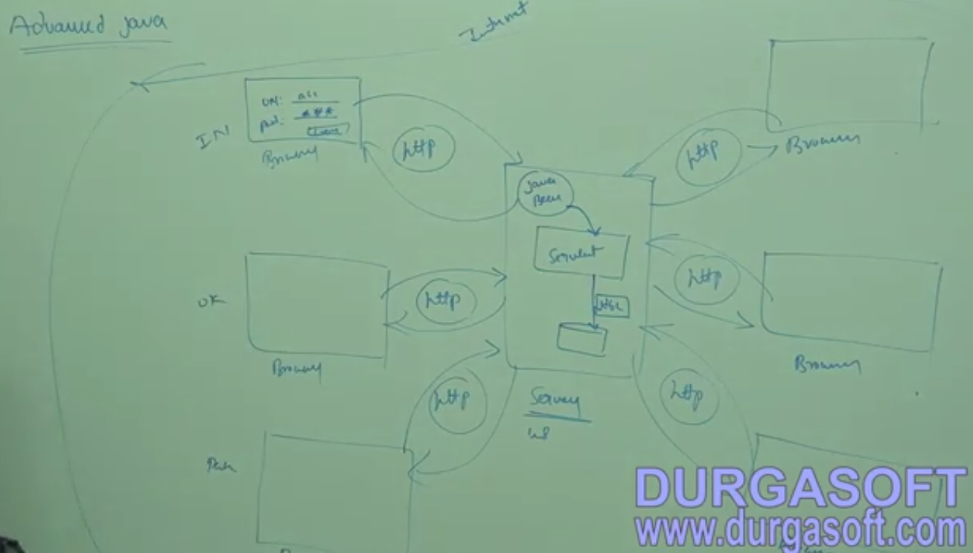
2. 02.ADV Java MVC
   1. 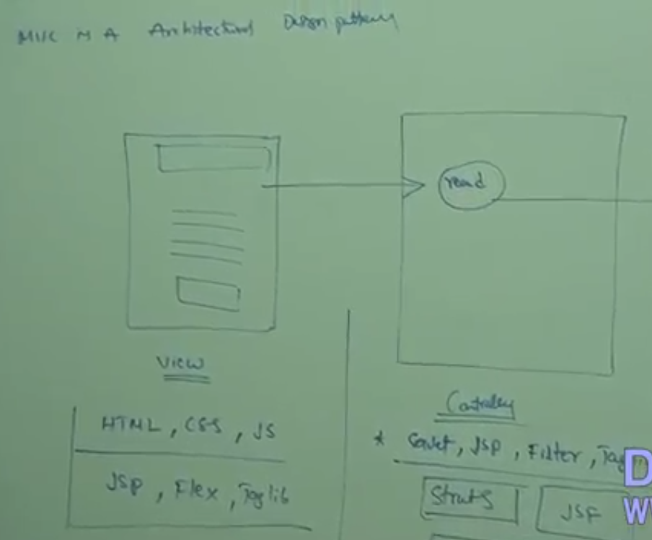
   2. 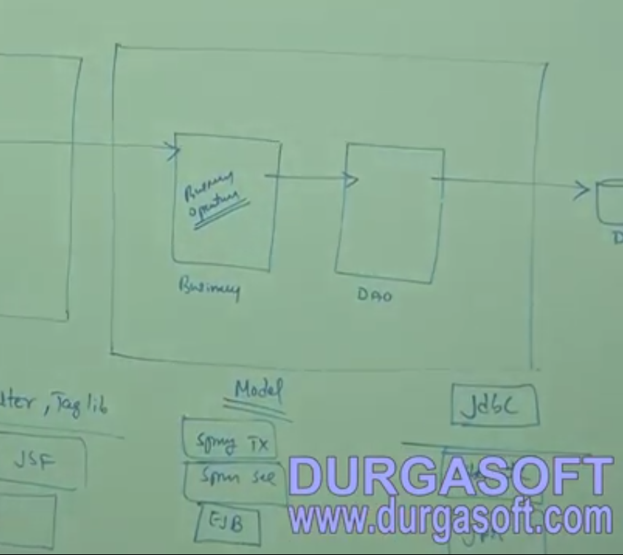
3. 03.ADV Java JDBC Architecture Part 1
   1. 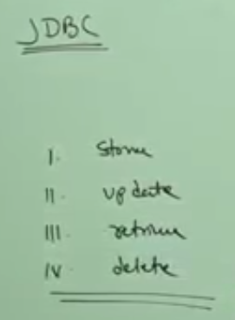
   2. 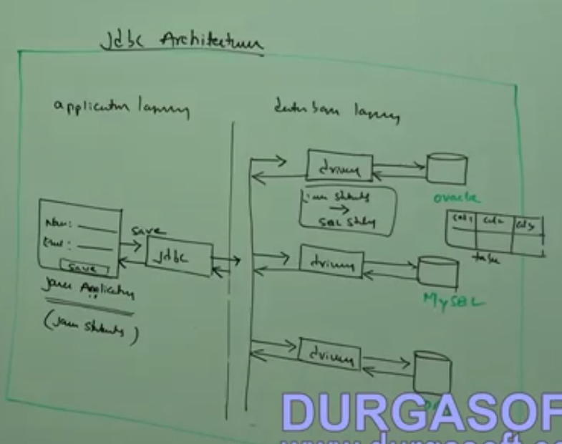
   3. 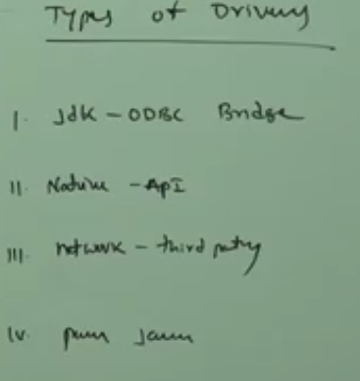
   4. 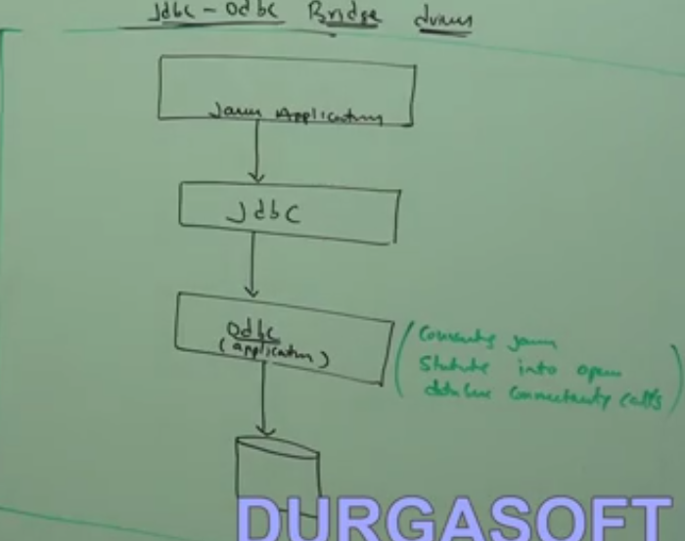
   5. The Java application, Database and ODBC must be in same machine, so it is best suited for standalone application only.
4. 04.ADV Java JDBC Architecture Part 2
   1. 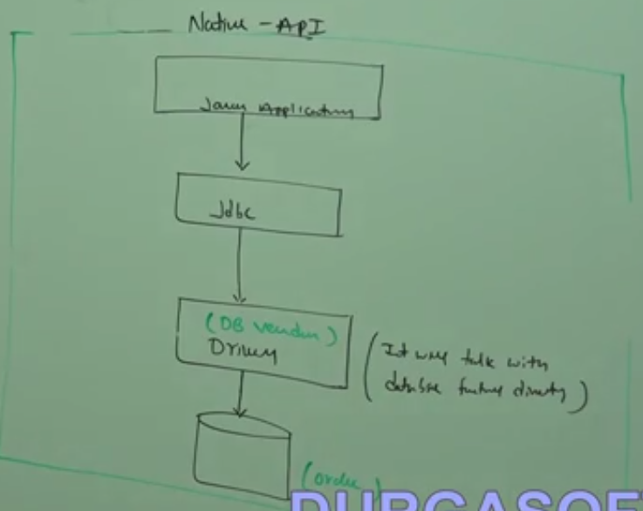
   2. It can be used for standalone and remote database.
5. 05.ADV Java JDBC Architecture Part 3
   1. sample program for type 1
   2. 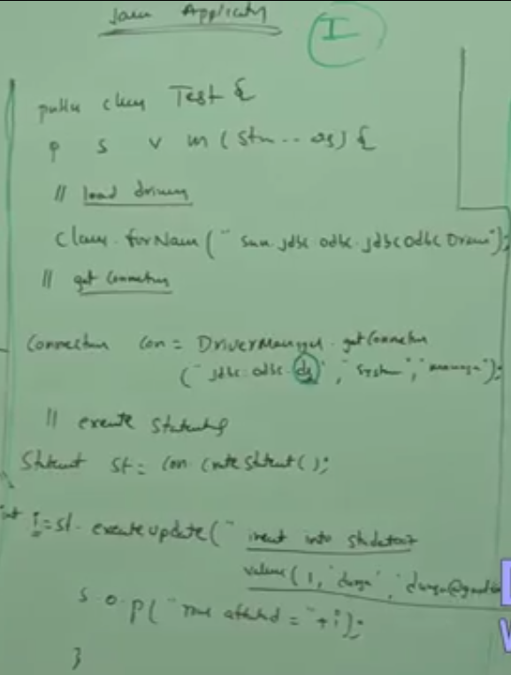
6. 06.ADV Java JDBC Architecture Part 4
   1. 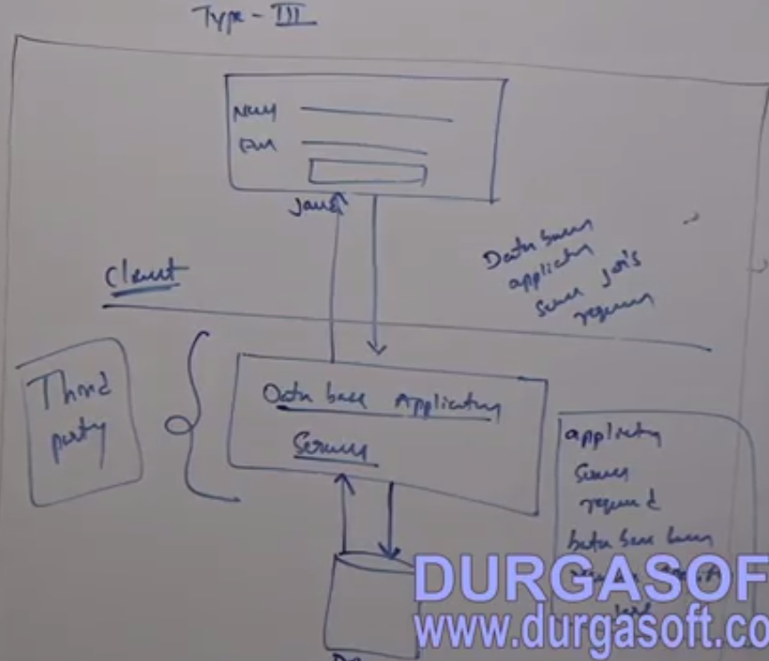
   2. Type 4
   3. 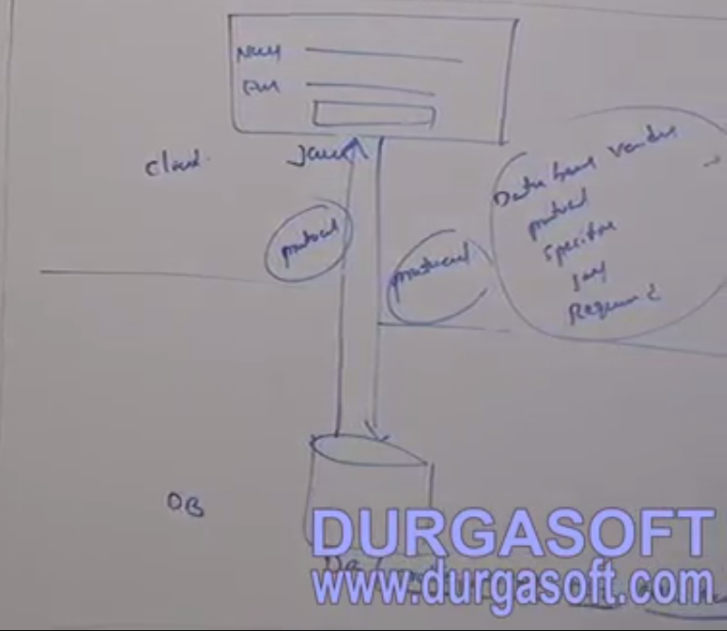
   4. Main classes that need to be used in JDBC
   5. 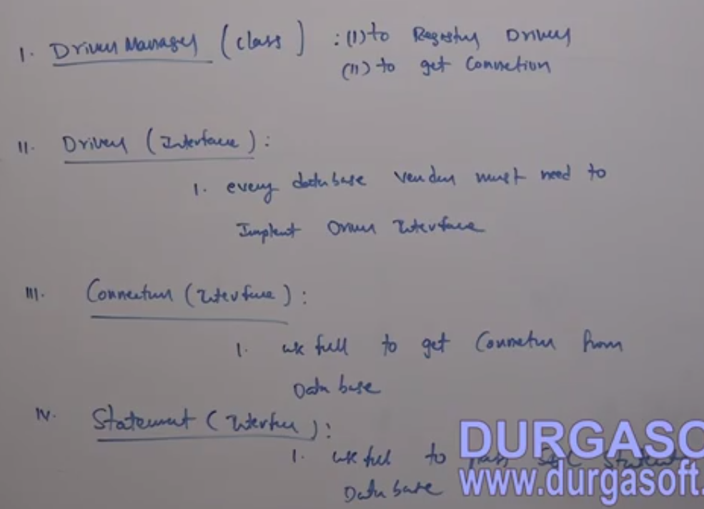
   6. 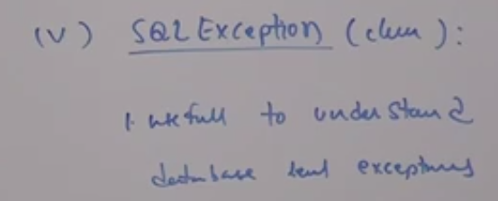
7. 07.ADV Java Steps to Connect with DataBase Part 1
   1. 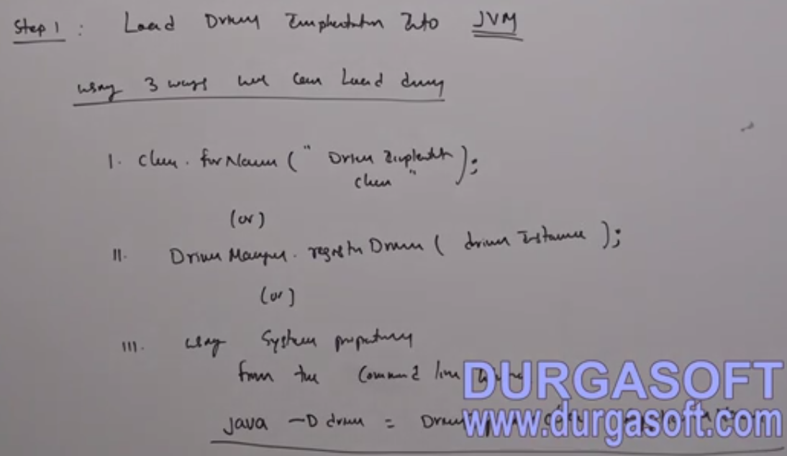
   2. 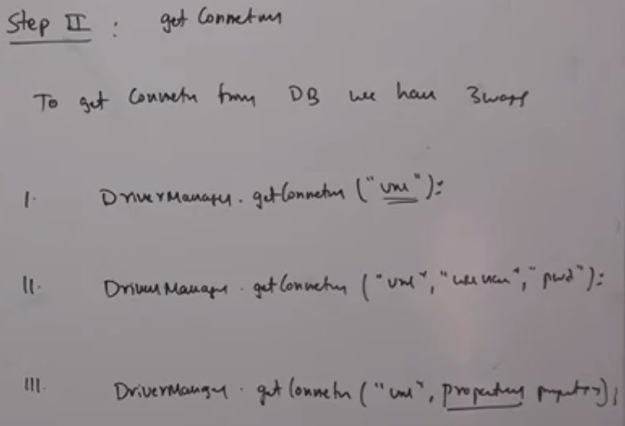
   3. 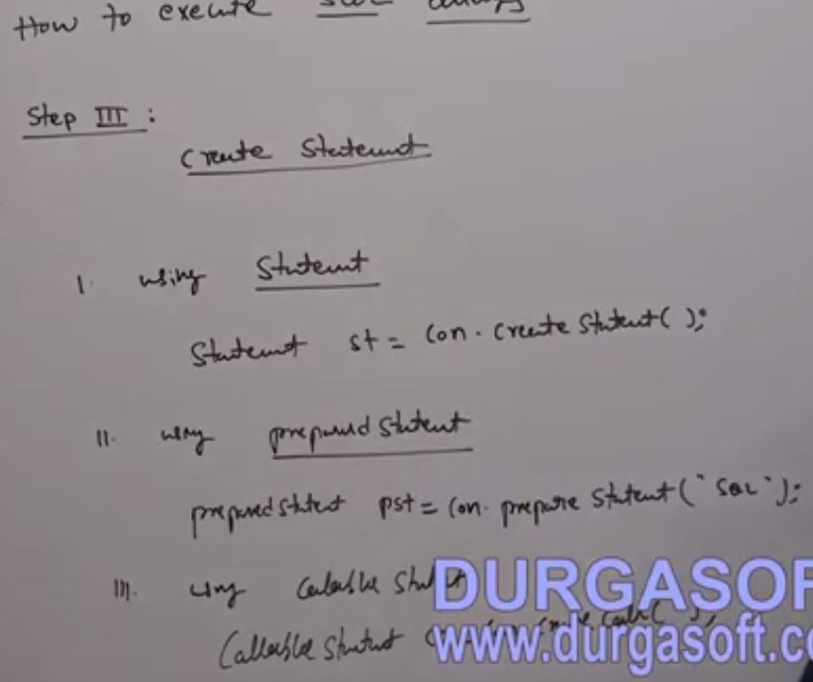
   4. 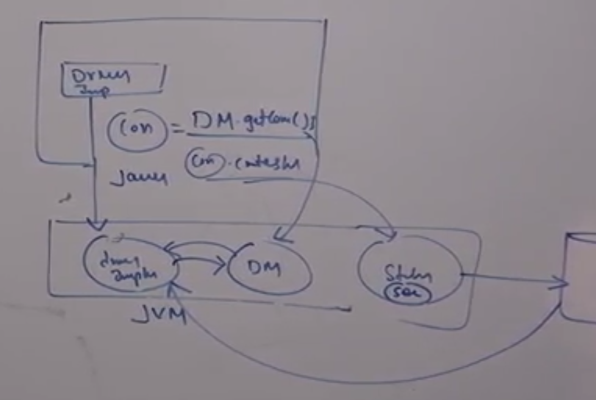
8. 08.ADV Java Steps to Connect with DataBase Part 2
   1. 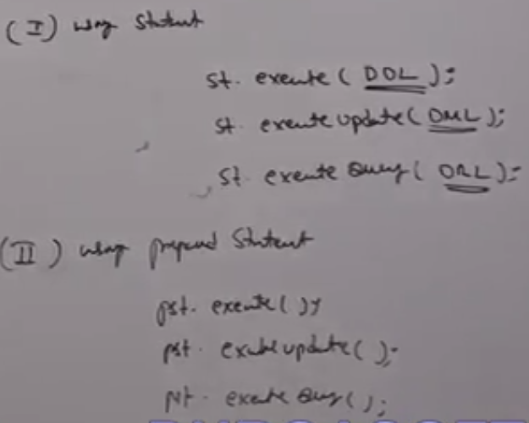
   2. DDL - Create, alter, drop, truncate, rename.
   3. DML - Insert, Update, Delete.
   4. DRL - Select
   5. 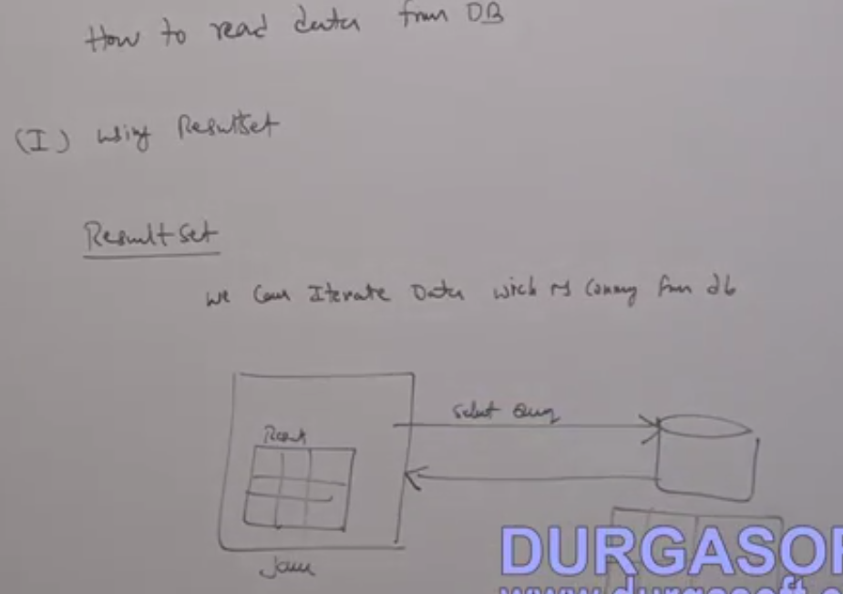
9. 09.ADV JAVA Steps to Connect with DataBase Part 3
10. 10.ADV JAVA Steps to Connect with DataBase Part 4
    1. 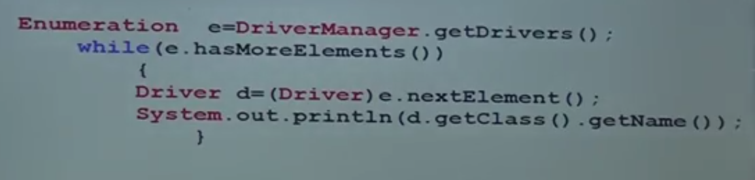
    2. 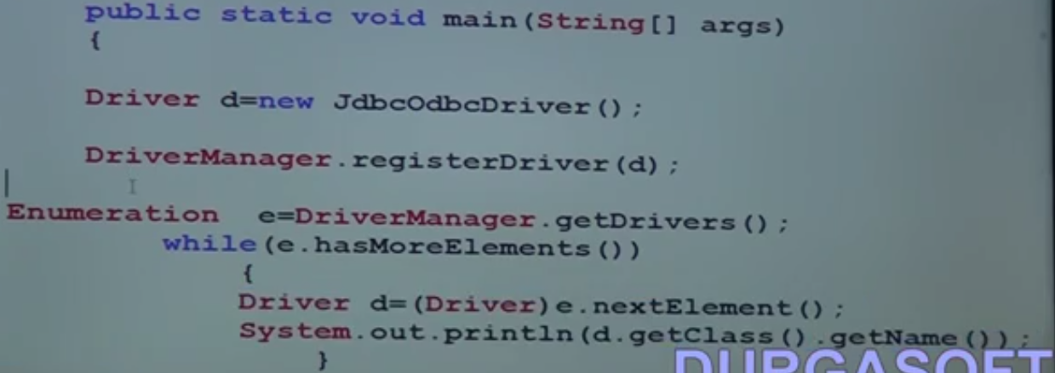
11. 11.ADV JAVA Steps to Connect with DataBase Part 5
    1. 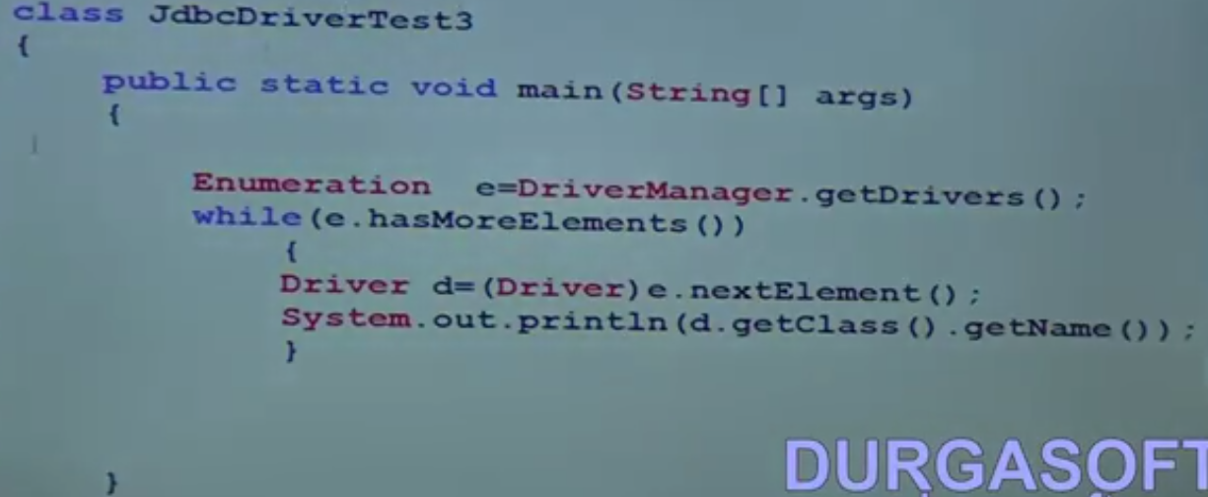
    2. 
    3. Get connection from Database
12. 12.ADV Java Steps to Connect with DataBase Part 6
    1. 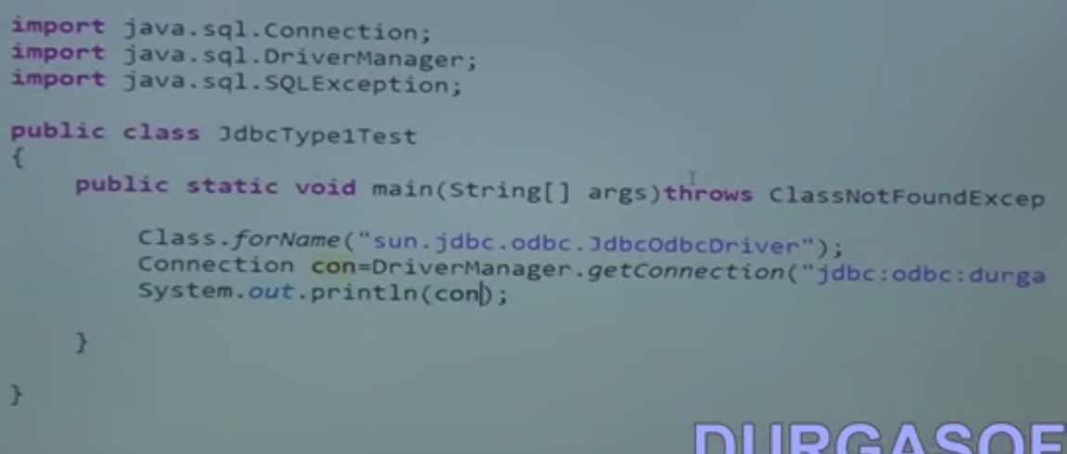
13. 13.ADV Java Steps to Connect with DataBase Part 7
    1. 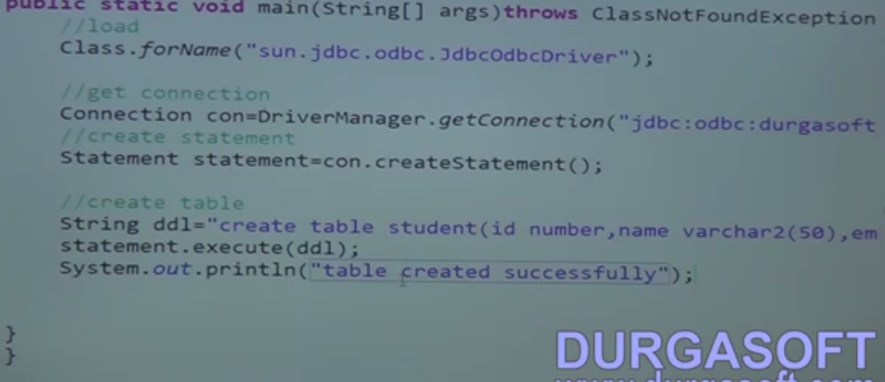
14. 14.ADV Java Steps to Connect with DataBase Part 8
    1. 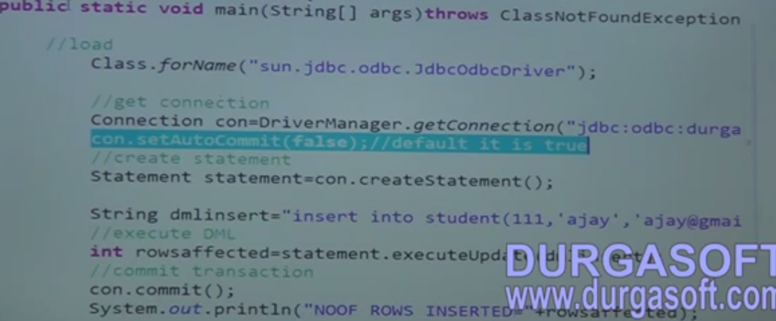
    2. 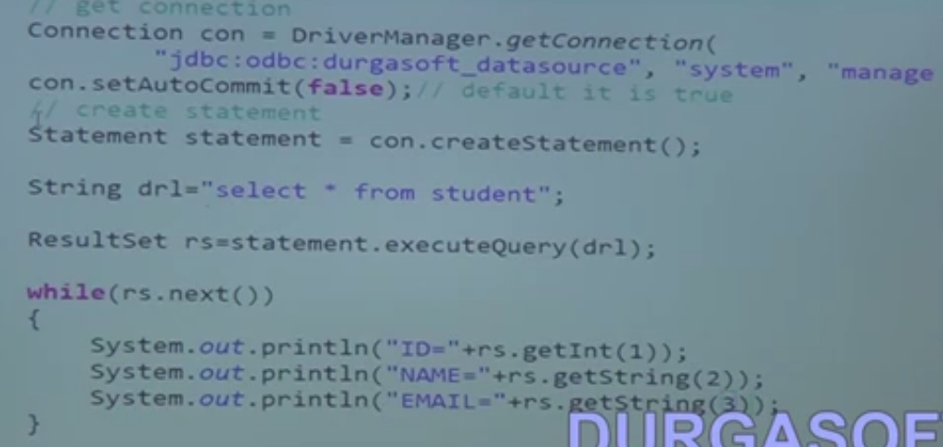
15. 15.ADV Java Steps to Connect with DataBase Part 9
16. 16.ADV Java Steps to Connect with DataBase Part 10
    1. 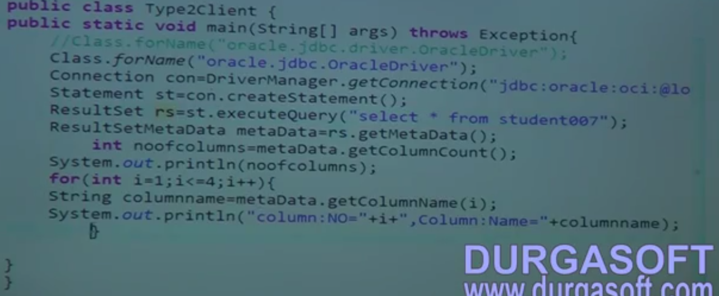
17. 17.ADV Java Steps to Connect with DataBase Part 11
    1. 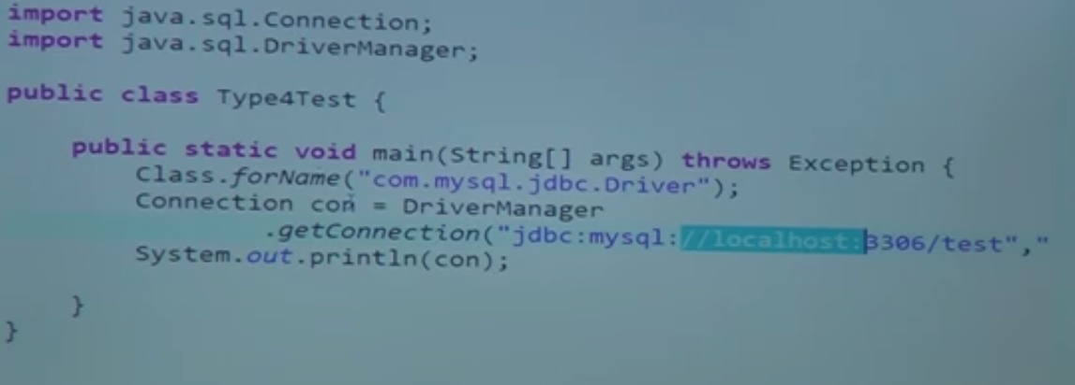
18. 18.ADV Java Steps to Connect with DataBase Part 12
19. 18.ADV Java Steps to Connect with DataBase Part 12
20. 20.ADV Java Steps to Connect with DataBase Part 14
    1. 
    2. 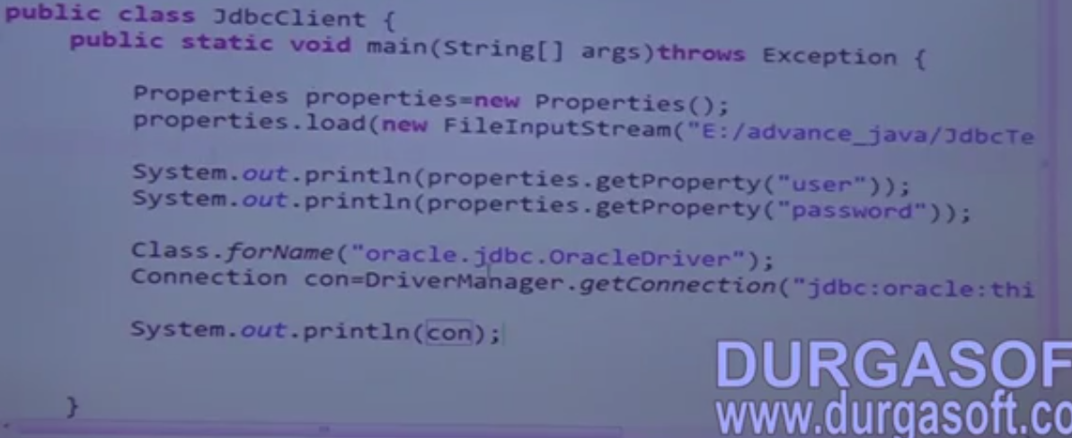
21. 21.ADV Java Steps to Connect with DataBase Part 15
    1. 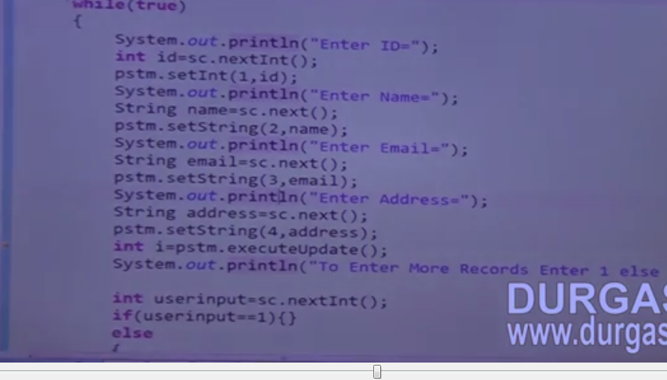
22. 22.AdvJava Servlets Container Part 1
    1. Servlets are server side java classes
    2. To run Servlets we need a container
    3. Whenever request comes from a browser, the container will read it and convert it into **HttpServletReq.**
    4. Then the container will transfer the request to the relevant Servlet.
    5. Then the Servlet will send the response to the container.
    6. now container converts the Response to Http protocol data.
    7. 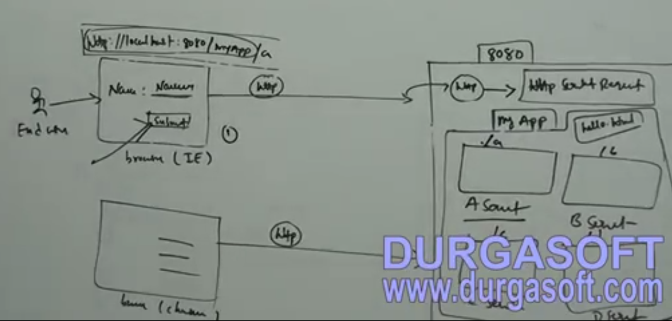
23. 23.AdvJava Servlets Container Part 2
    1. Directory Structure
    2. 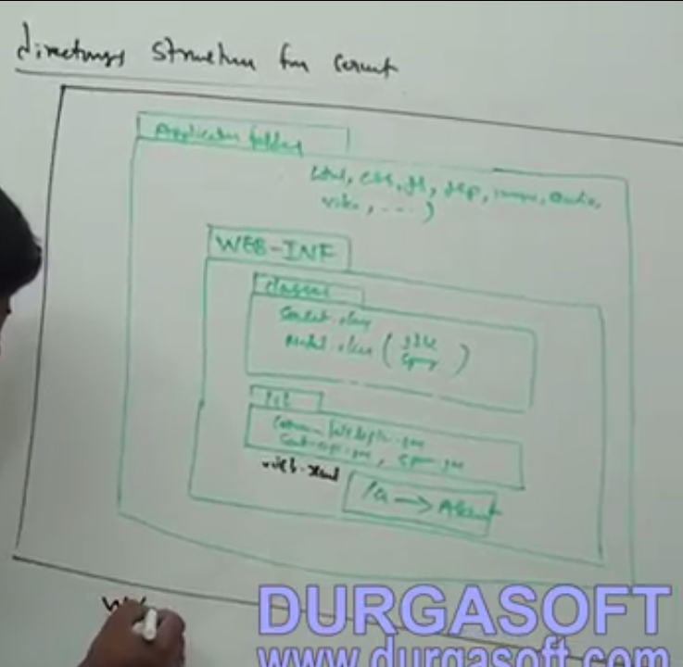
    3. Load on start up tag in web.xml is set to 1 to make the container to create objects in the start up
24. 24.AdvJava How to Write a Servlet Part 1
    1. 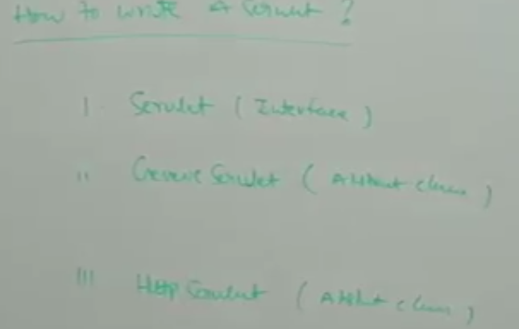
    2. Our Servlet needs to implement any of the above.
    3. If we implement Servlet, we need to override the below method
    4. 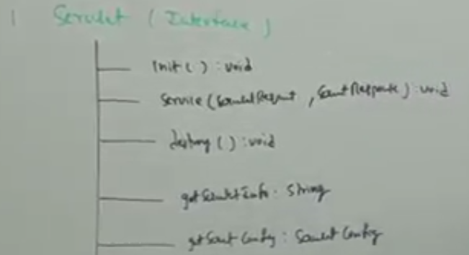
    5. 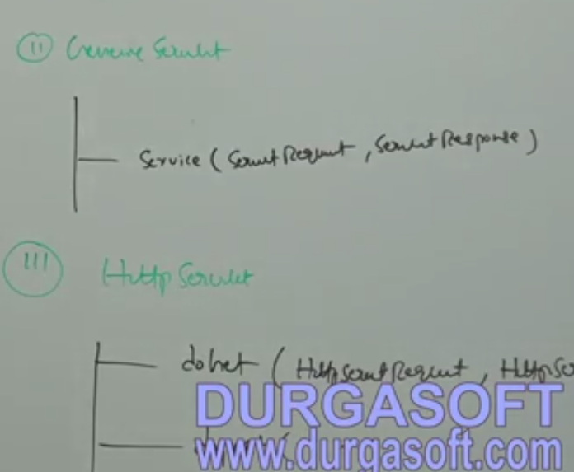
    6. Using get we can transfer only 256 chars, but using post we can transfer unlimited chars
    7. Hello world by implementing Servlet
25. 25.AdvJava How to Write a Servlet Part 2
26. 26.AdvJava Hello World Example Part 2
    1. 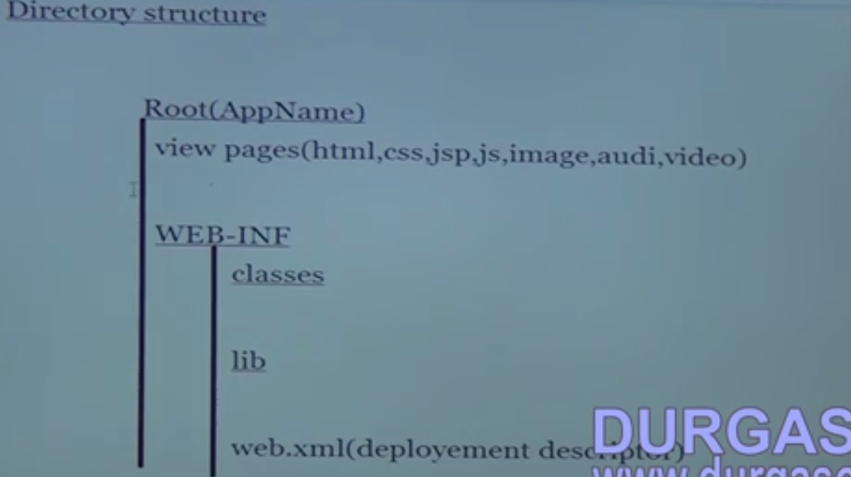
    2. 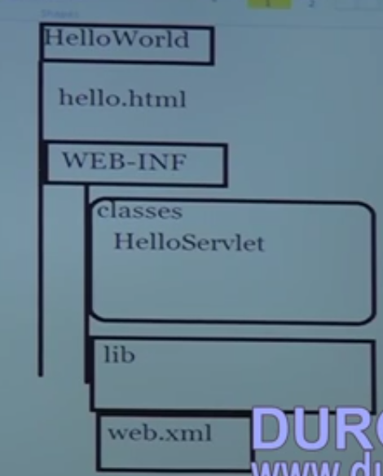
    3. 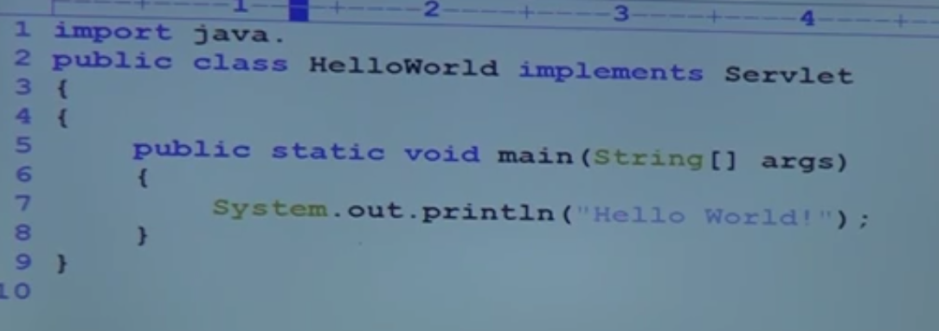
27. 27.AdvJava Hello World Example Part 2
    1. 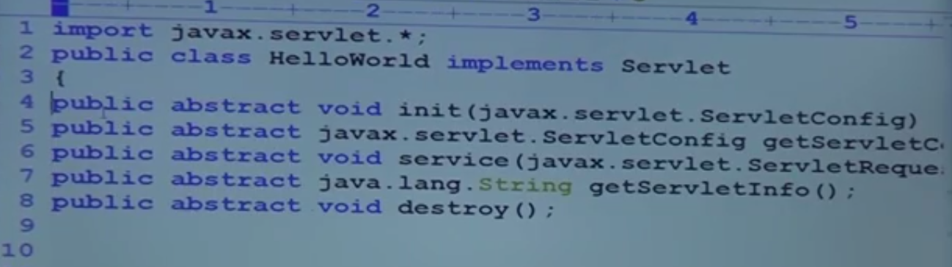
    2. 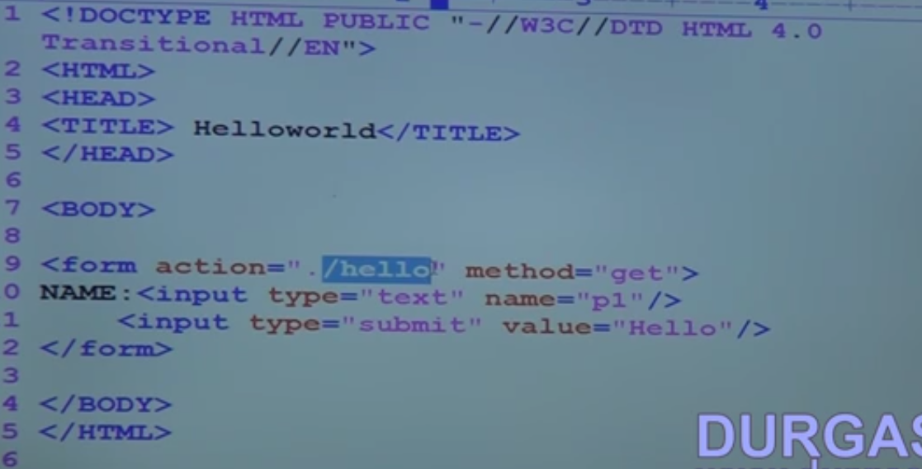
    3. 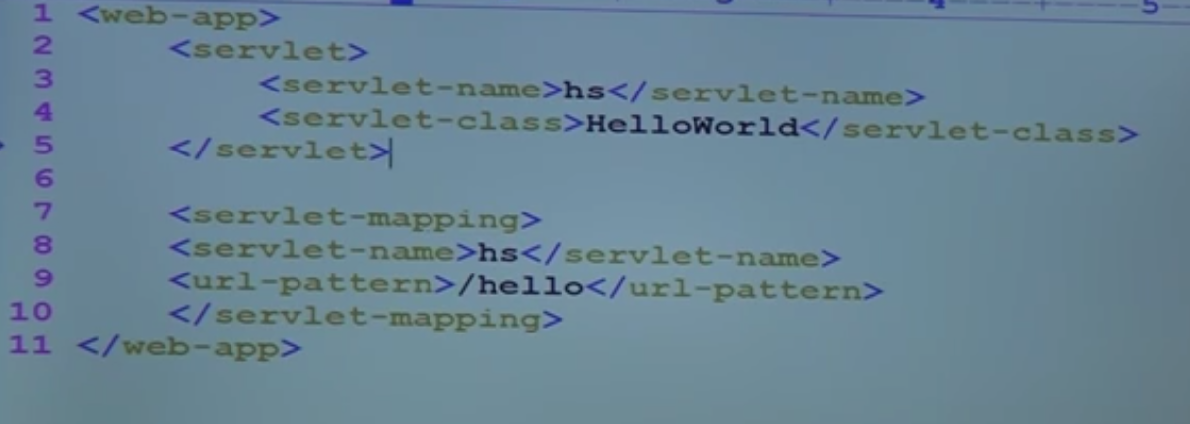
28. 28.AdvJava Hello World Example Part 3
29. 29.AdvJava Servlets Life Cycle Part 1
    1. When a container is started, all the Servlets in war will be extracted and will be deployed.
    2. if the set load on start up for the given Servlets, then Servlet object will created on stating the Container . else the Servlet will be created on the first request.
    3. Then additionally it will create two more object, A public shared ServletContext Object for all the Servlets and Private ServletConfig object for each Servlets.
    4. 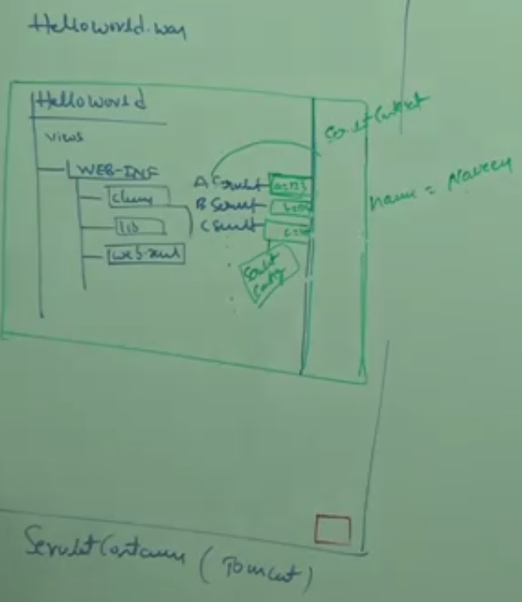
    5. 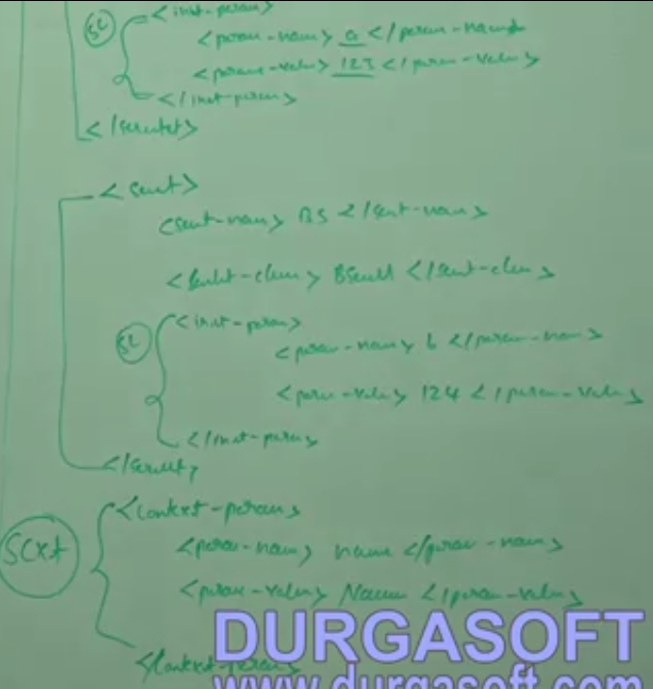
30. 30.AdvJava Servlets Life Cycle Part 2
    1. Whenever the servlet object is created init() will be executed, and for further request only service() method will be executed. we have one more method Destroy() which is used for destroy purpose and executed when container is stopped.
31. 31.AdvJava Servlets Life Cycle Part 3
    1. 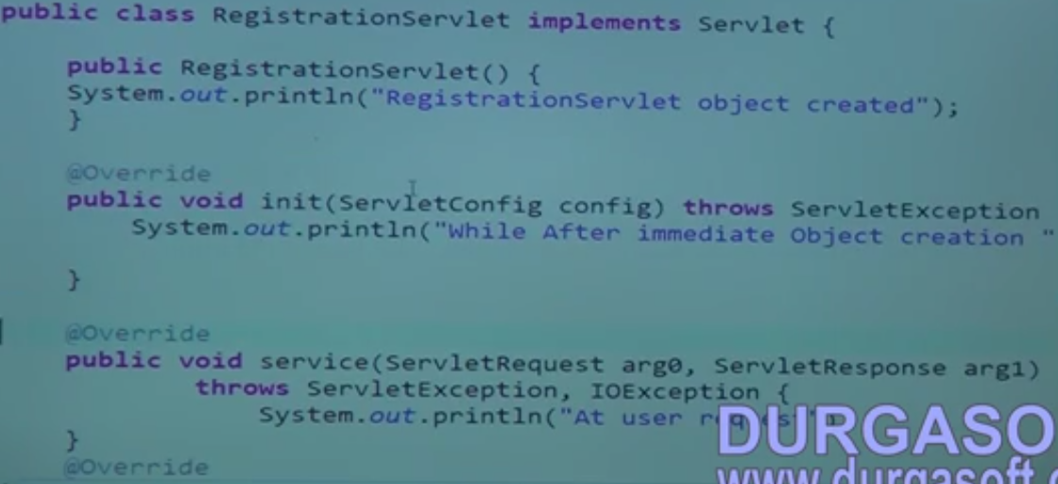
    2. 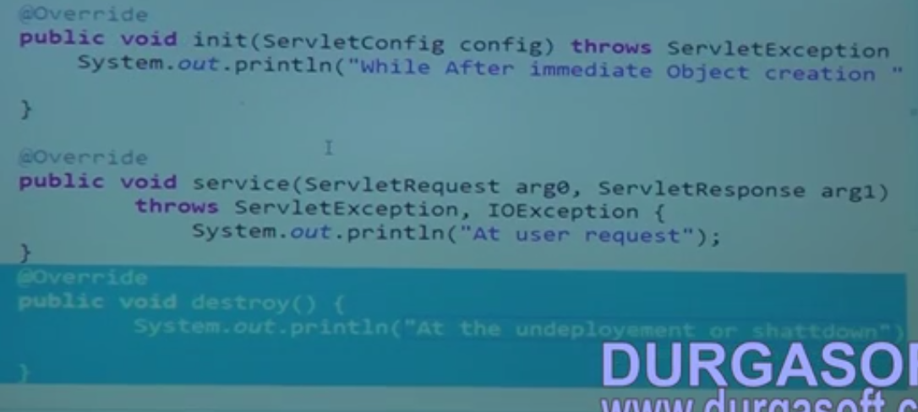
    3. 
    4. 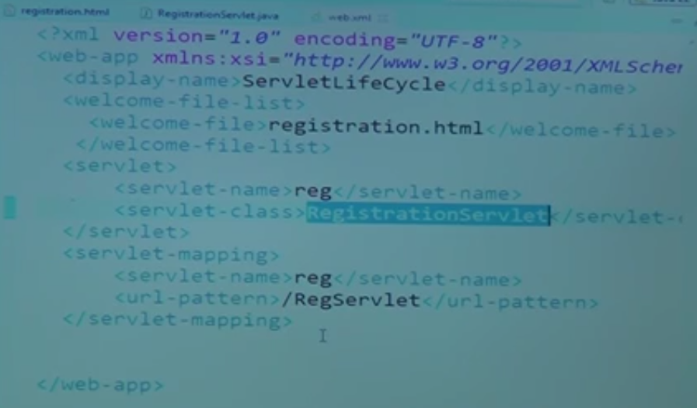
    5. 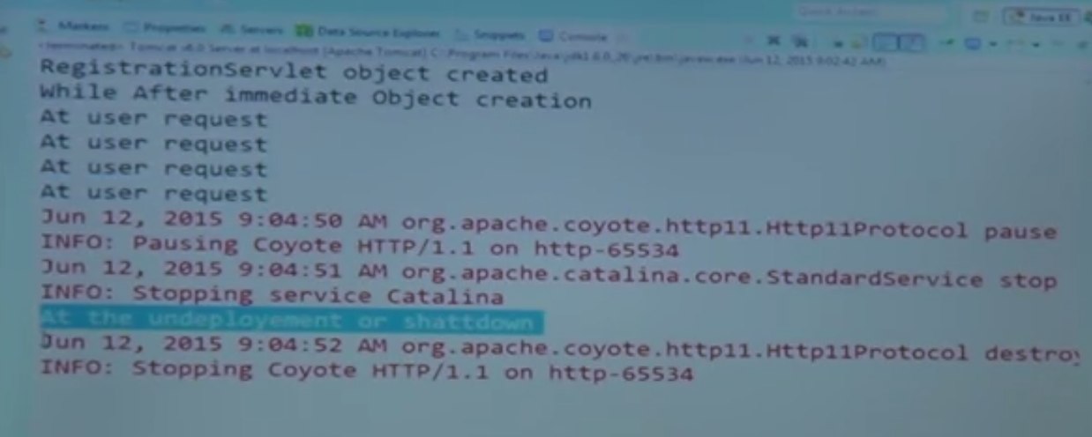
    6. 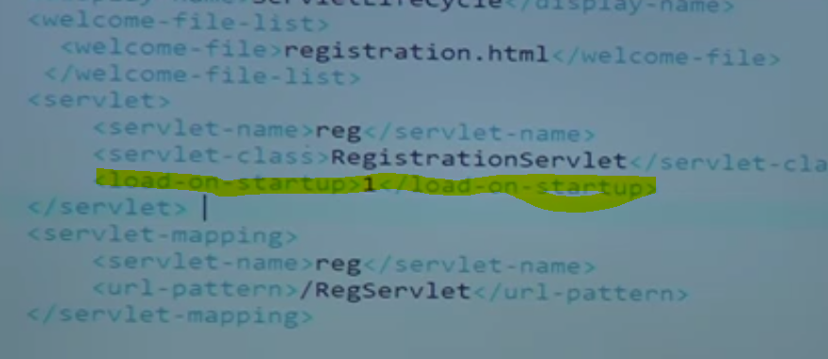
    7. 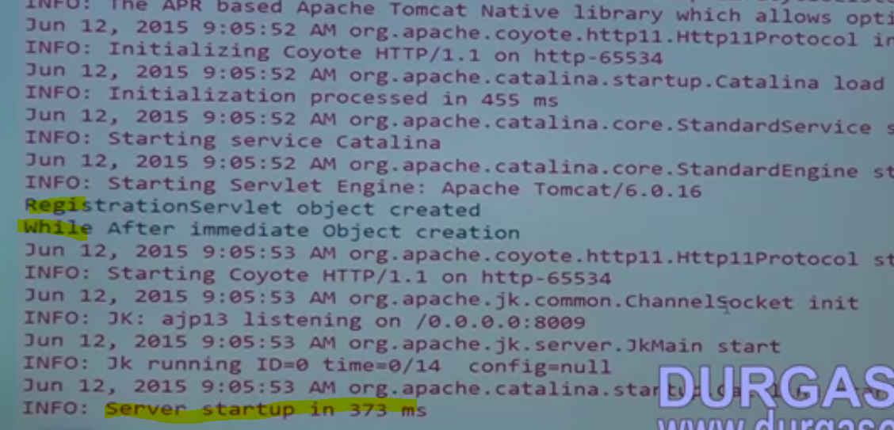
32. 32.Adv Java Servlets Life Cycle Part 4
    1. 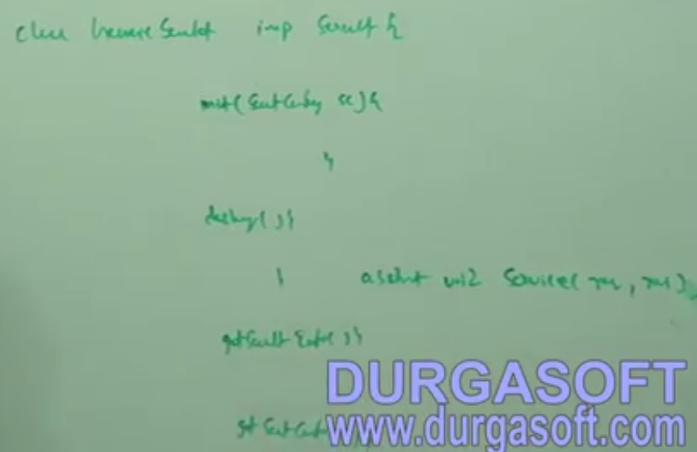
    2. Session management is not possible
33. 33.Adv Java Servlets Life Cycle Part 5
    1. Sample Generic Servlet
    2. 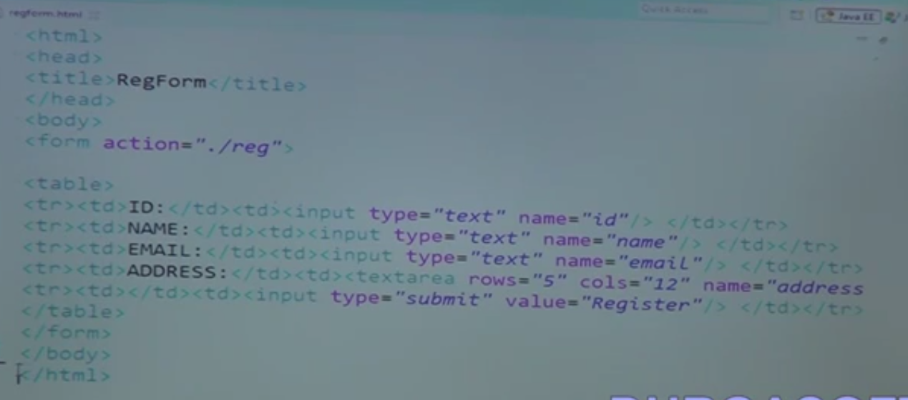
    3. 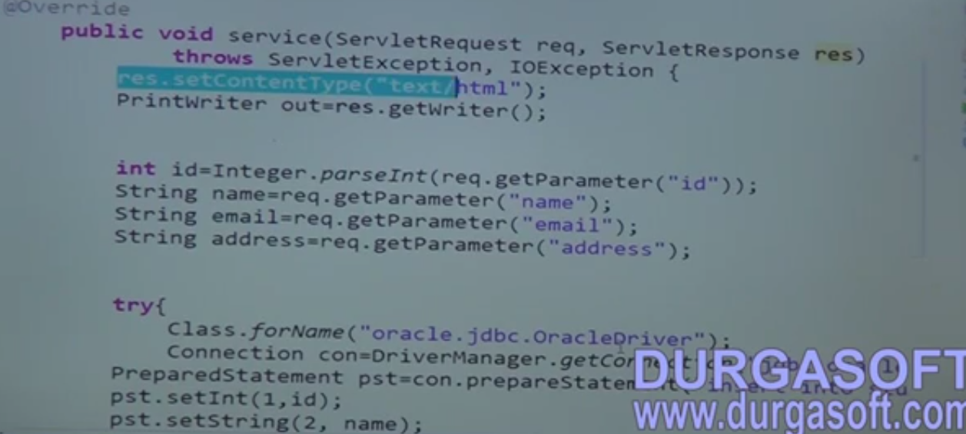
    4. 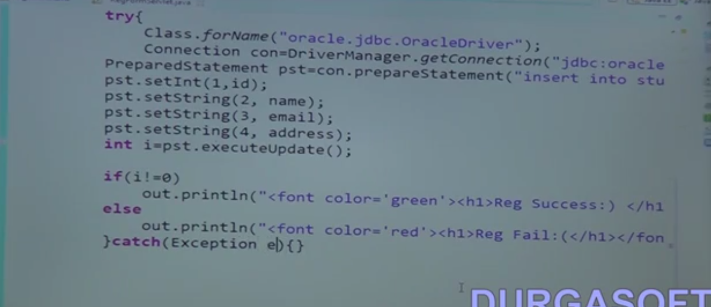
    5. 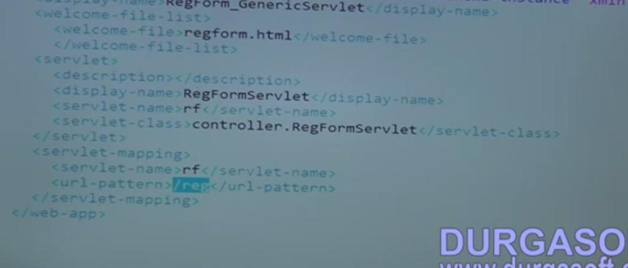
34. 34.Adv Java Servlets Life Cycle Part 6
    1. Java script validation
    2. 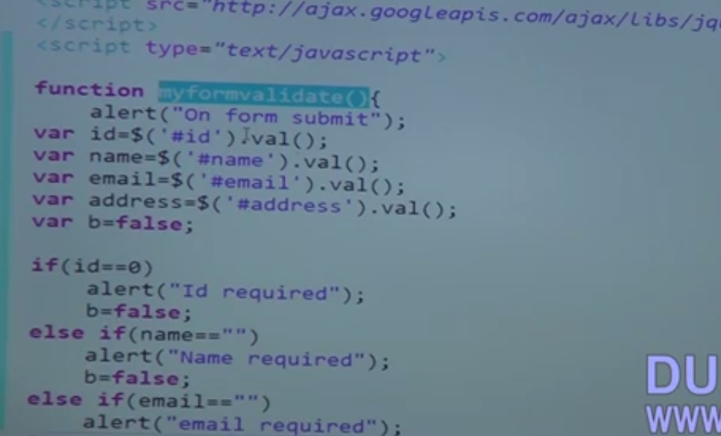
    3. 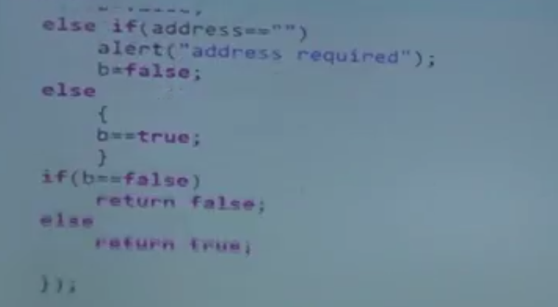
    4. 
35. 35.Adv Java-Context and Config Params-Part 1
    1. 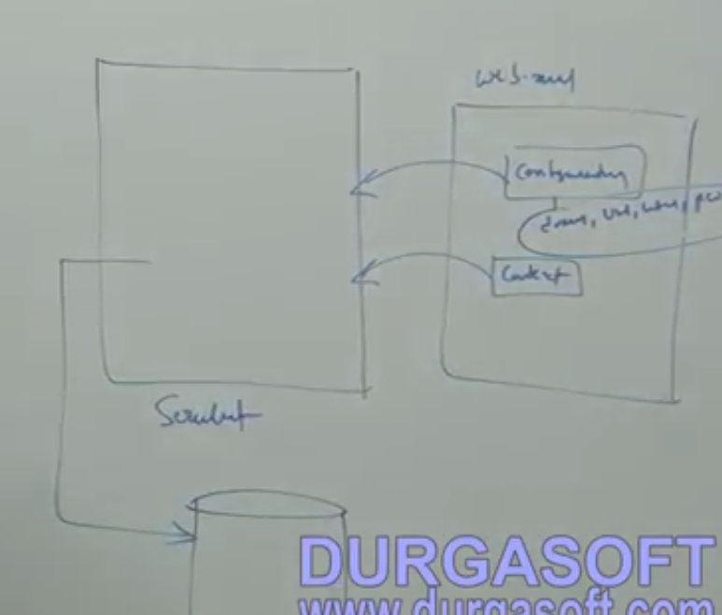
    2. 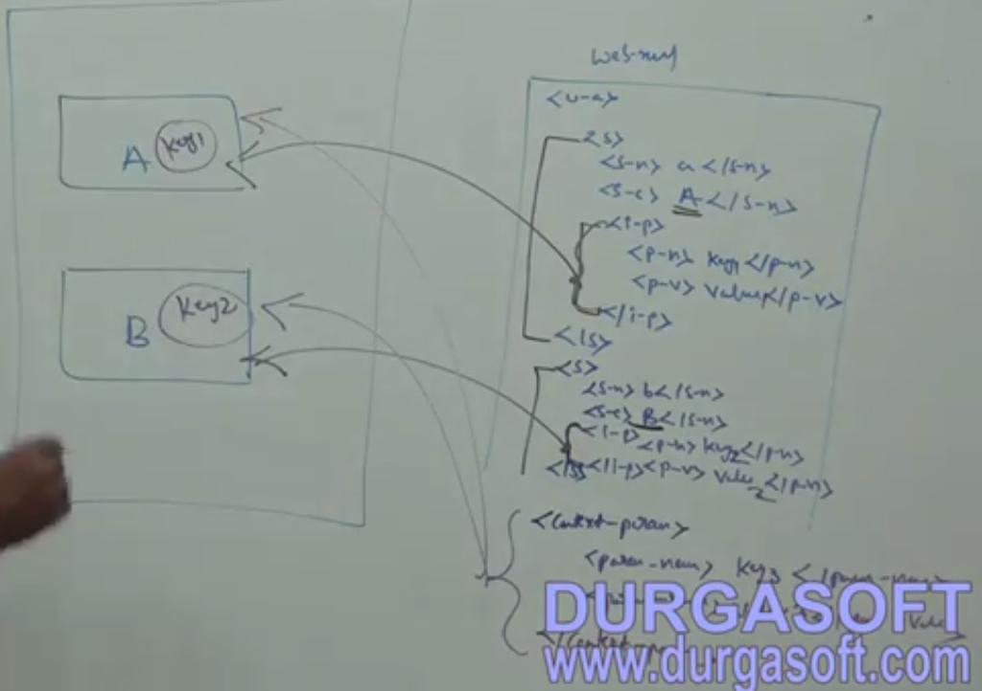
36. 36.Adv Java Context and Config Params Part 2
    1. 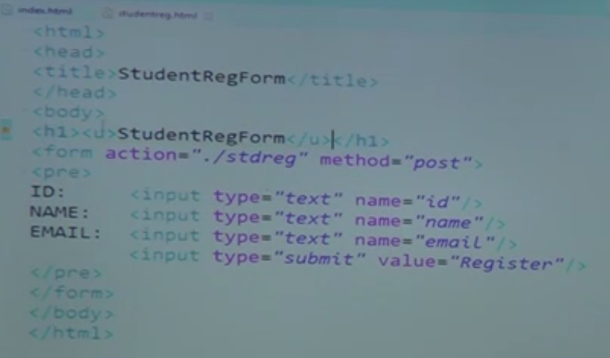
    2. 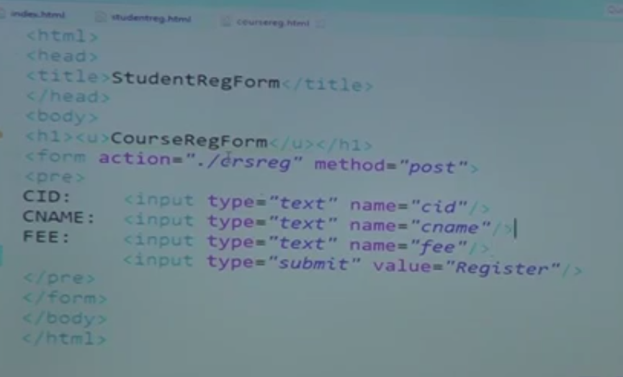
    3. 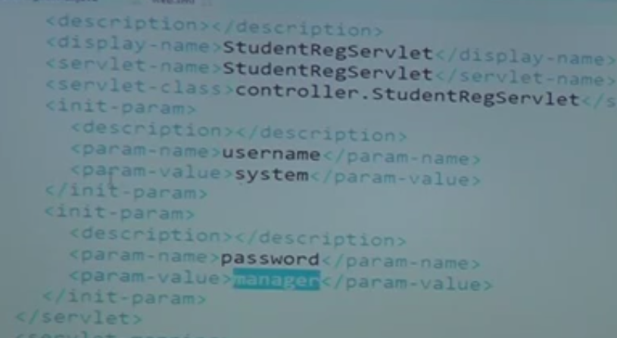
    4. 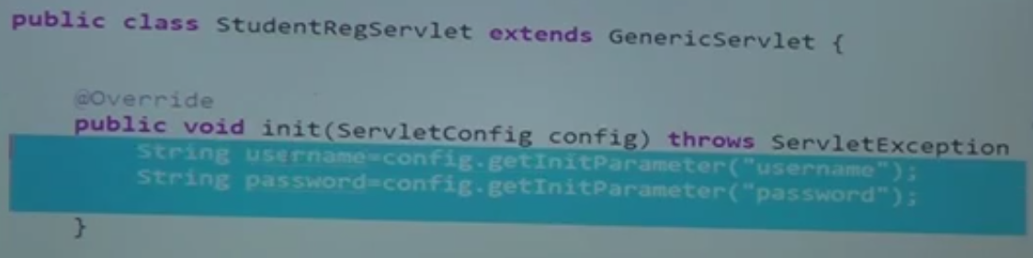
    5. 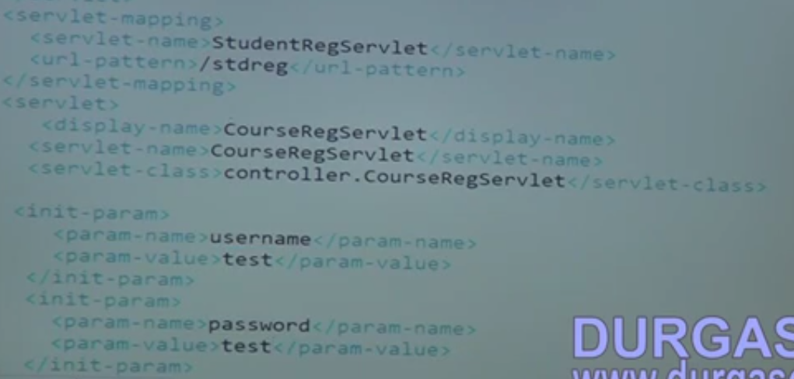
    6. 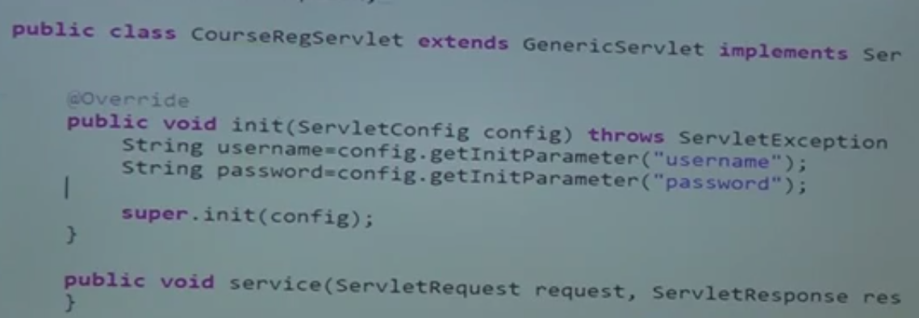
    7. 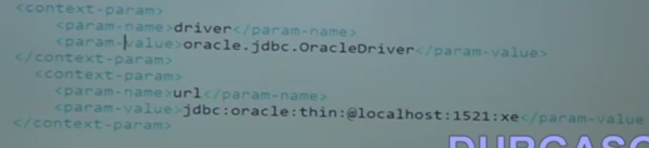
    8. 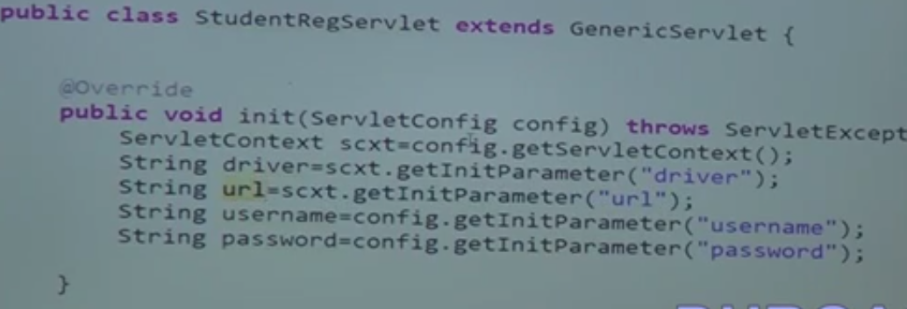
    9. 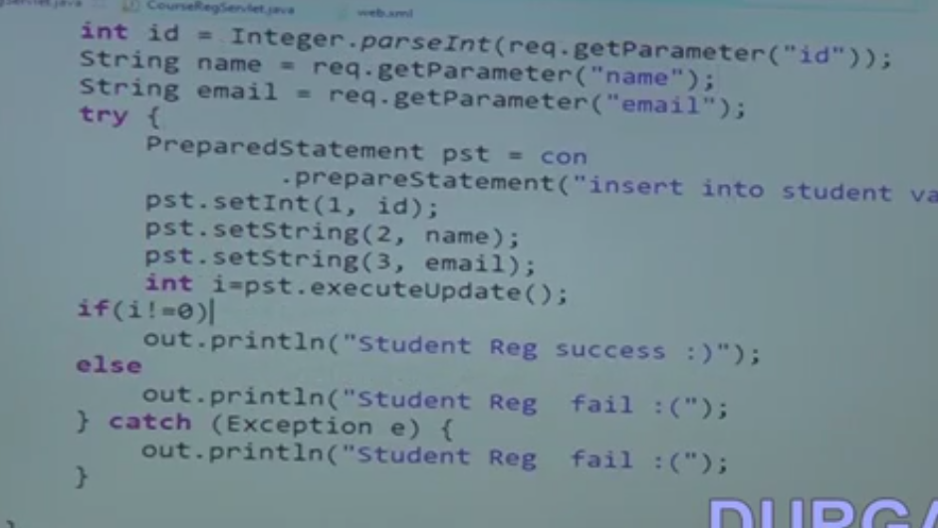
37. 37.Adv Java Context and Config Params Part 3
    1. Using JQuery to load both form in the same page
    2. 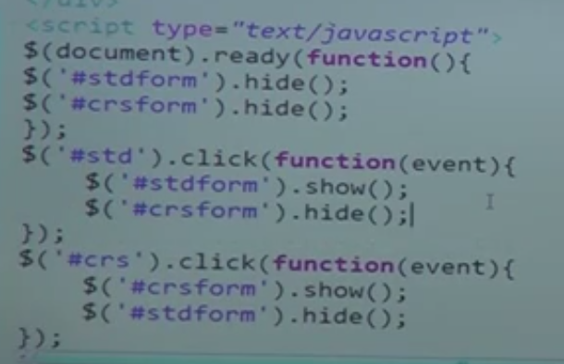
38. 38.Adv Java HTTP Servlet Part 1
    1. Multi from Data
    2. 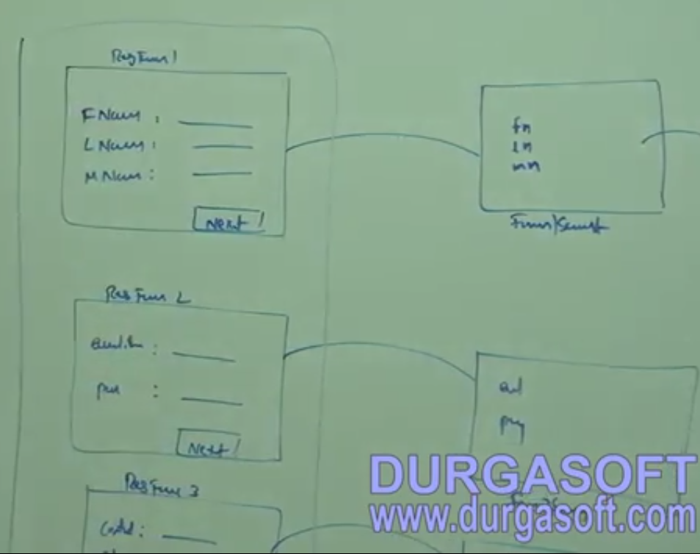
    3. 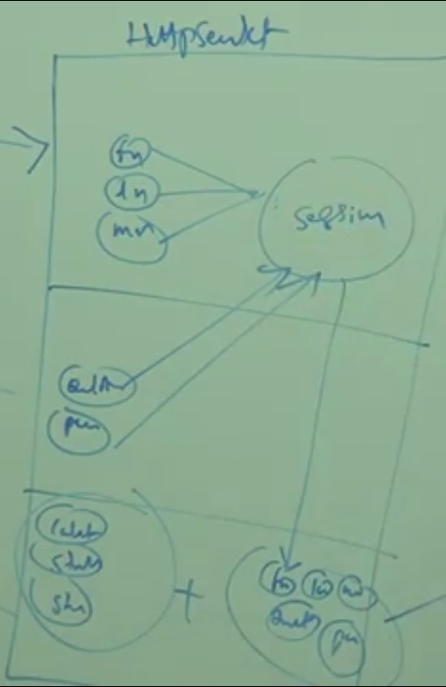
39. 39.Adv Java HTTP Servlet Part 2
    1. 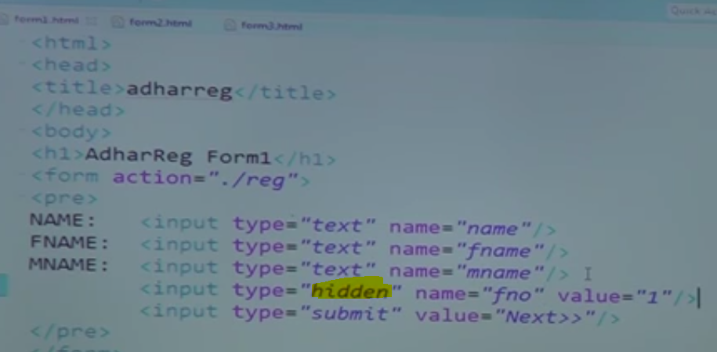
    2. 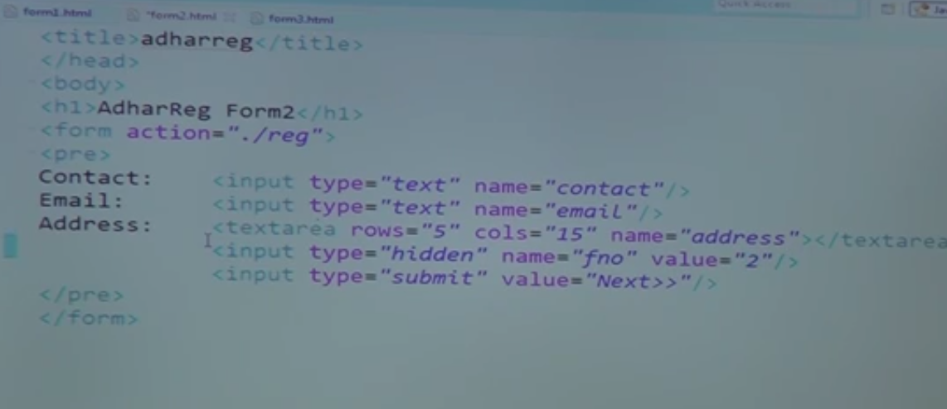
    3. 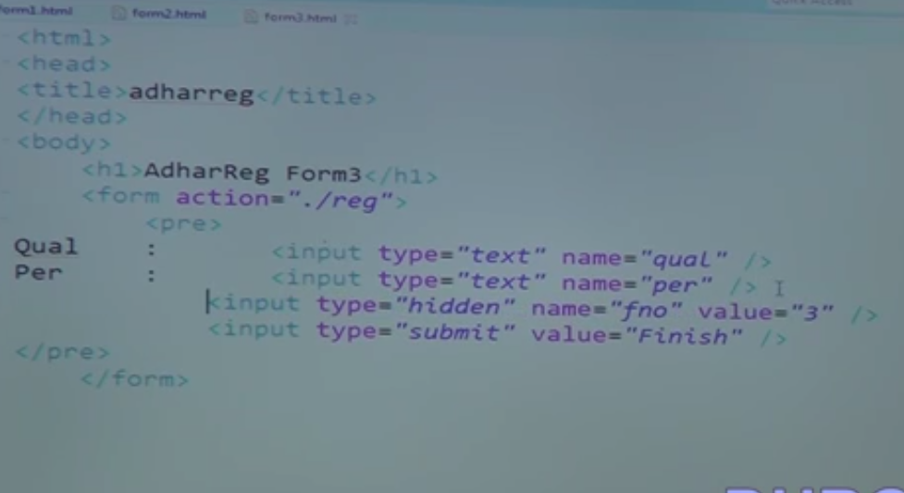
    4. 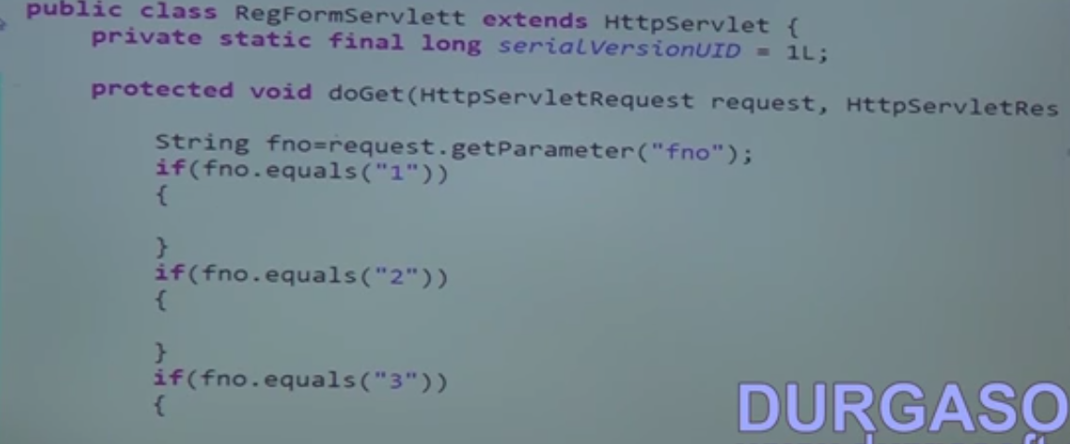
    5. 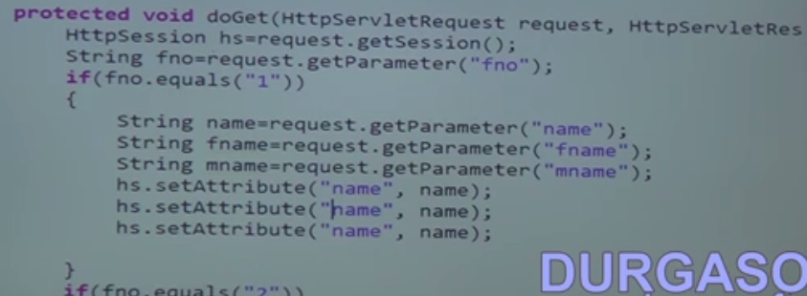
    6. 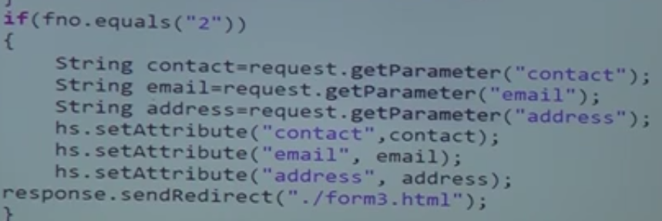
    7. 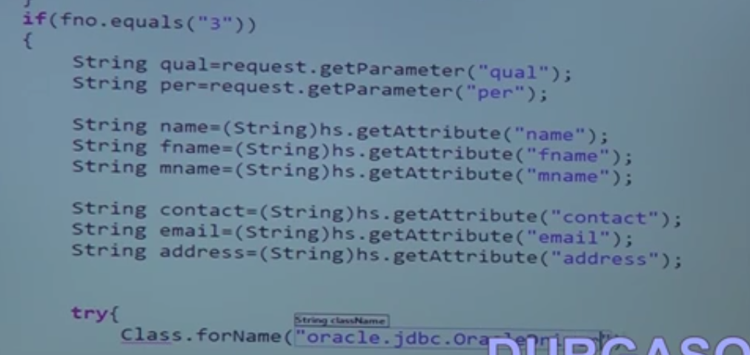
    8. 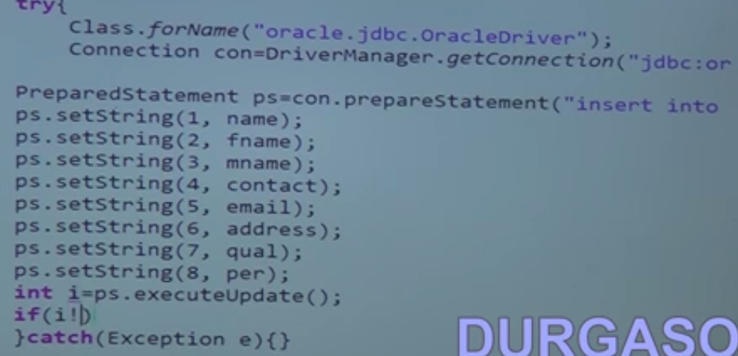
    9. 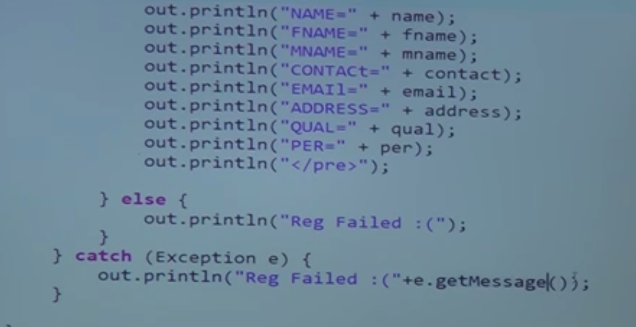
    10. 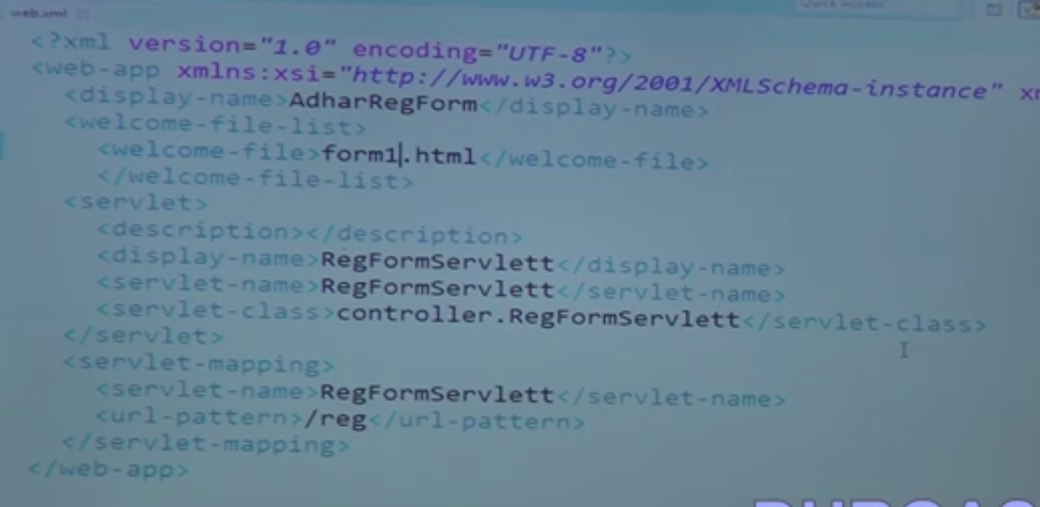
40. 40.Adv Java Servlet-Servlet Communication Part 1
    1. 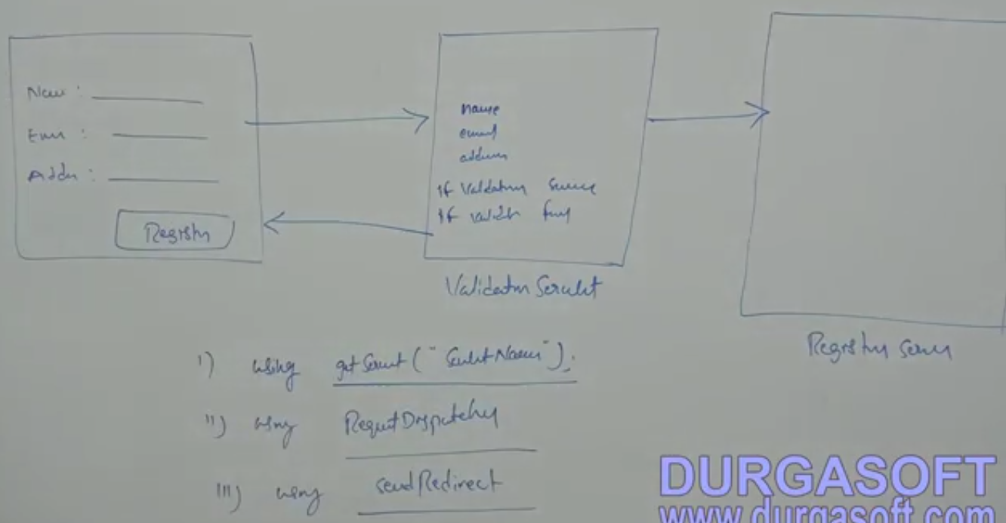
    2. Using Request dispatcher we can forward to other Servlet
41. 41.Adv Java Servlet-Servlet Communication Part 2
    1. 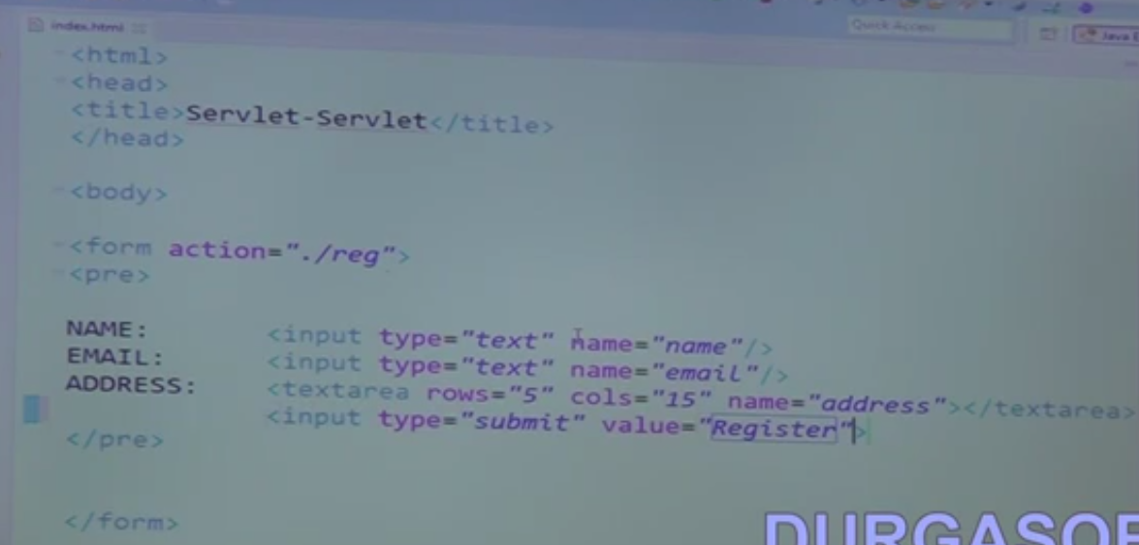
    2. 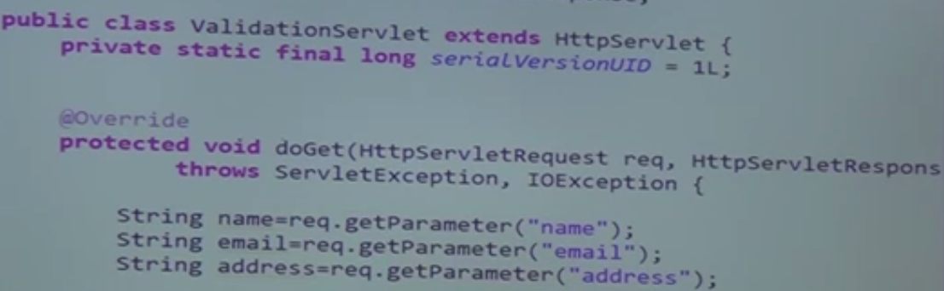
    3. 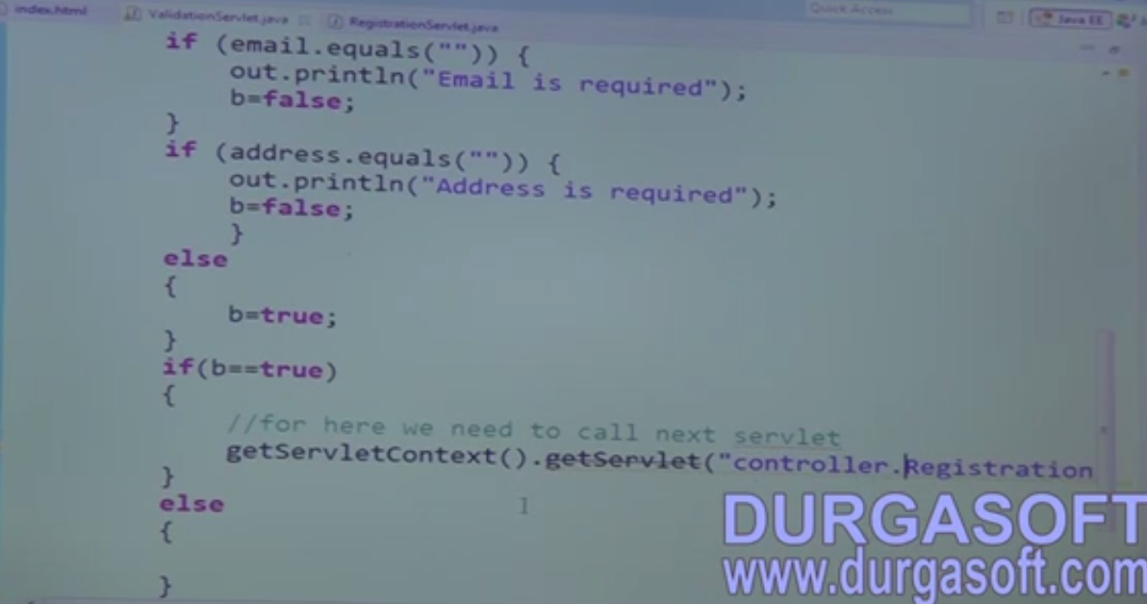
    4. 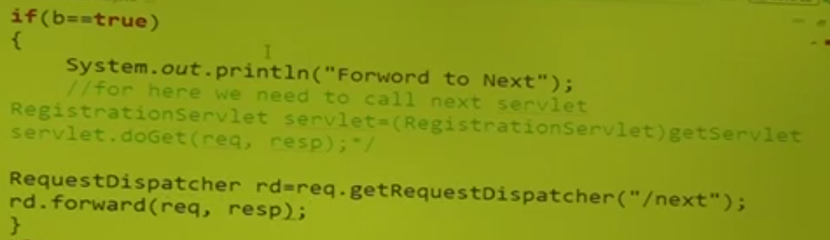
    5. 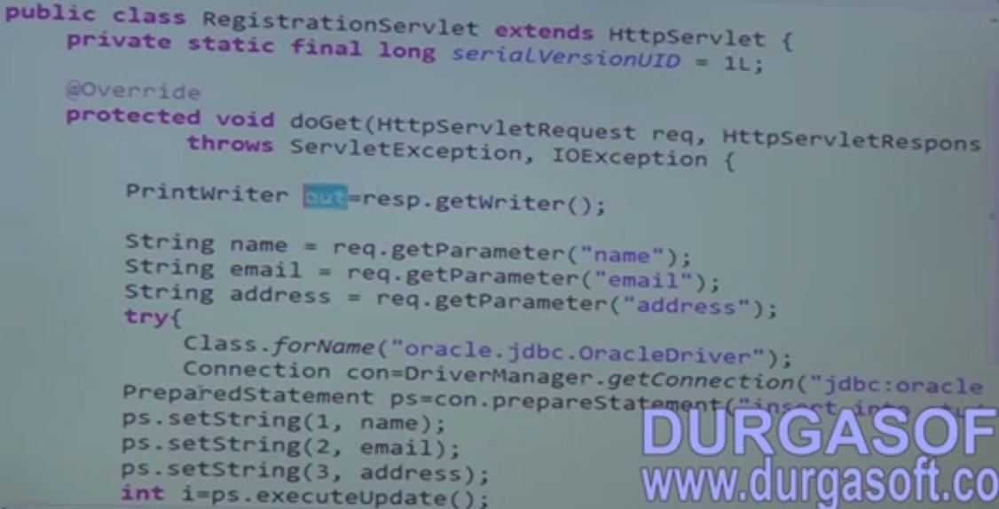
    6. 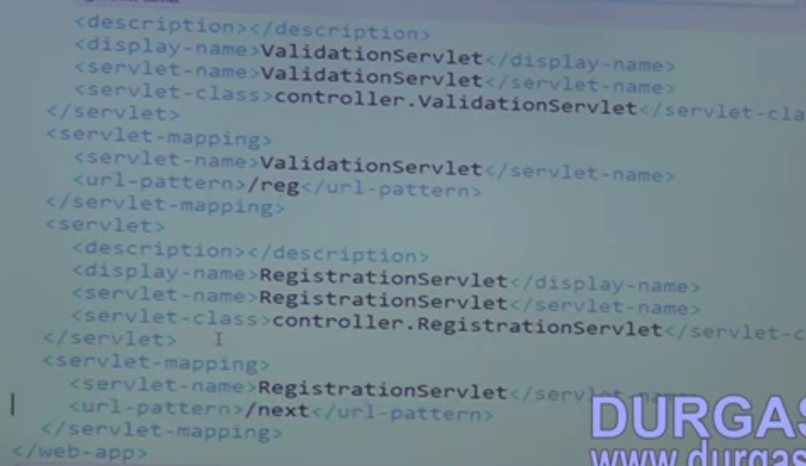
42. 42.Adv Java Servlet-Servlet Communication Part 3
    1. 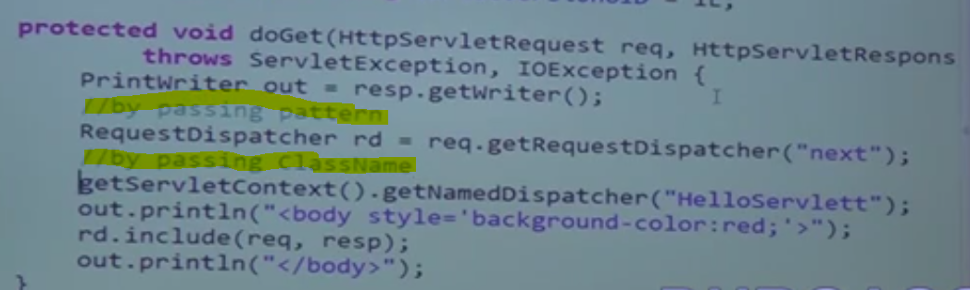
43. 43.Adv Java-AJAX-Servlet-Part 1
    1. 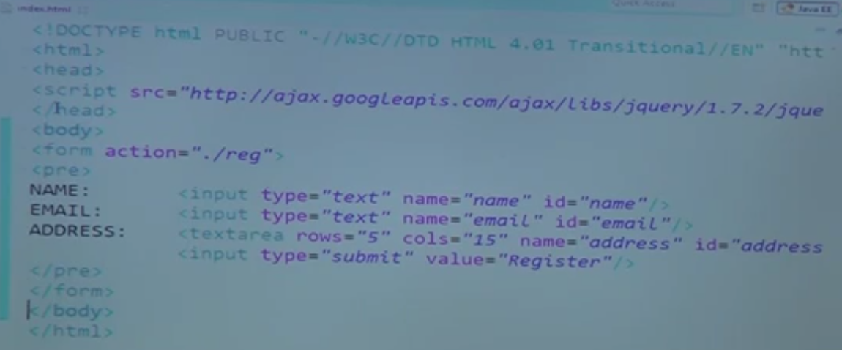
    2. 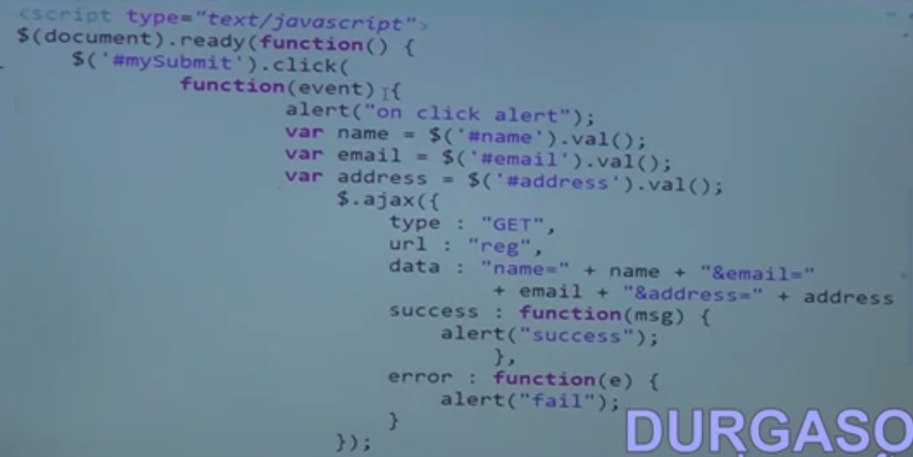
    3. 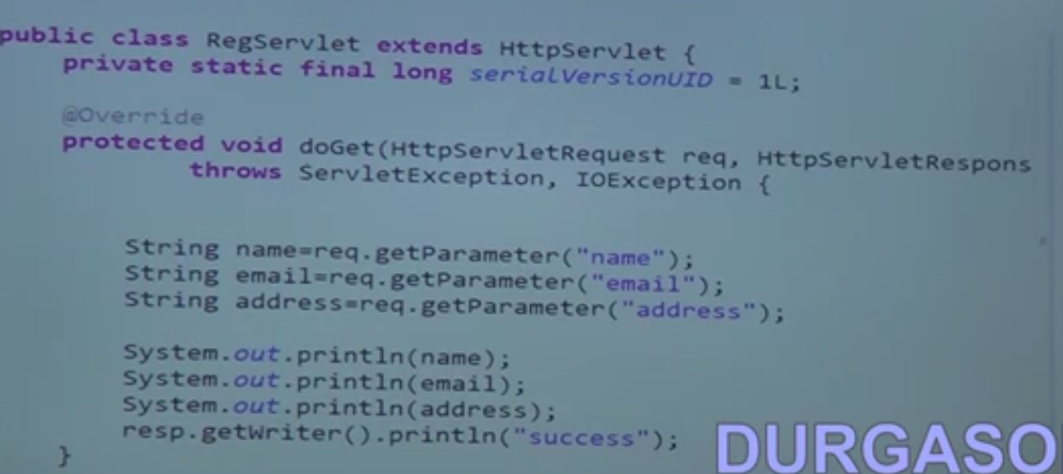
44. 44.Adv Java-AJAX-Servlet-Part 2
45. 45.Adv Java Filters Part 1
    1. If java script is disable in the client system then invalid data will be transferred to Servlet.
    2. So using filters we will filter the data before the form data reaches the Servlets
46. 46.Adv Java Filters Part 2
    1. 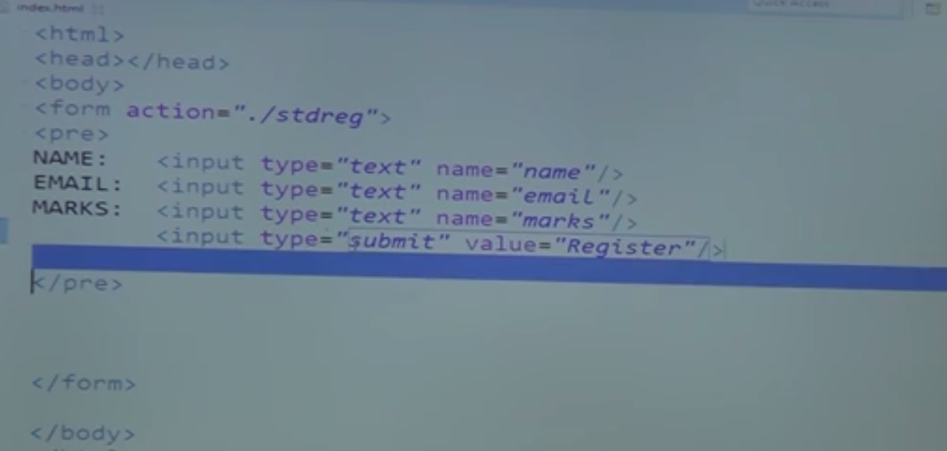
    2. 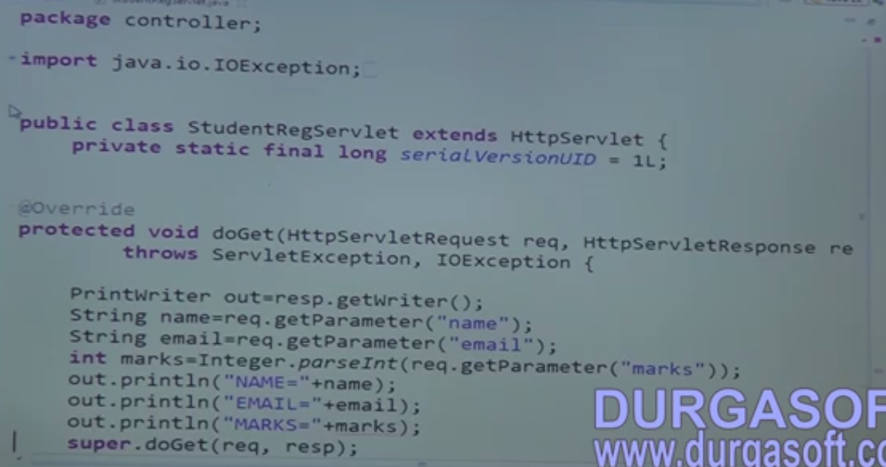
    3. 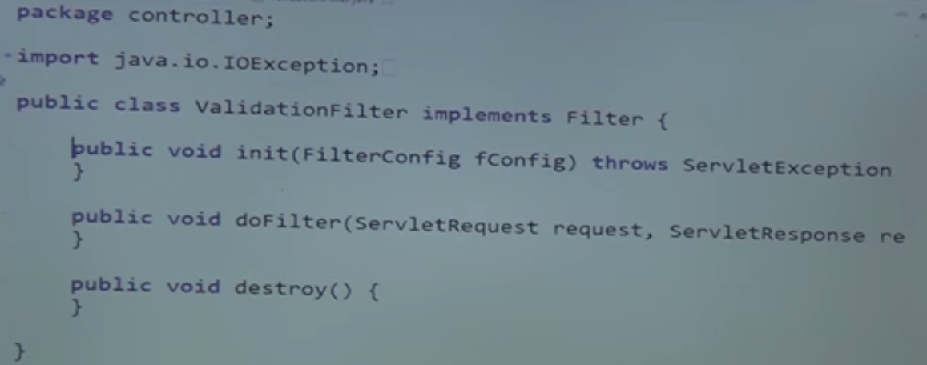
    4. 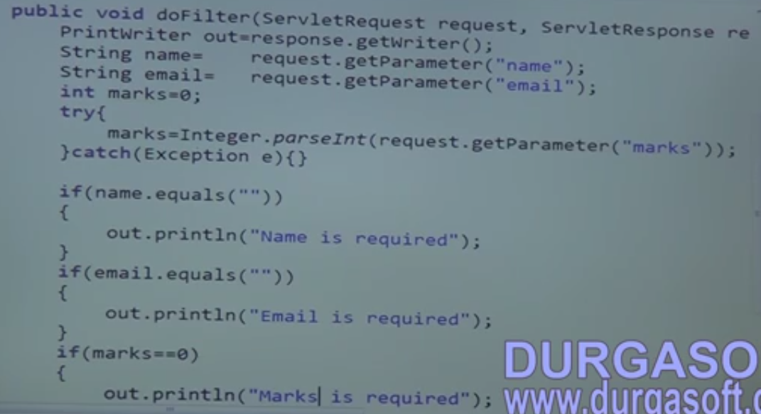
    5. 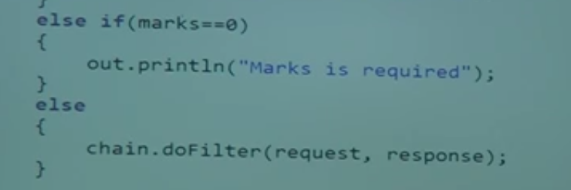
    6. 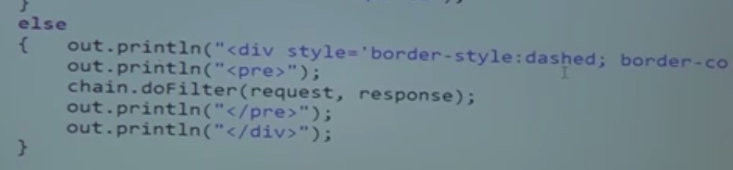
47. 47.Adv Java-Servlet Listners-Part 1
    1. Three types
       1. ServletContextListeners
       2. ServletSessionListener
       3. RequestListener
48. 48.Adv Java-Servlet Listners-Part 2
    1. ServletContextListeners
    2. 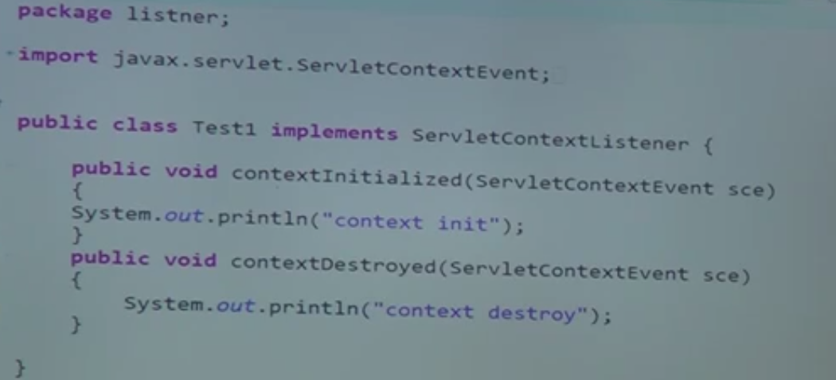
    3. 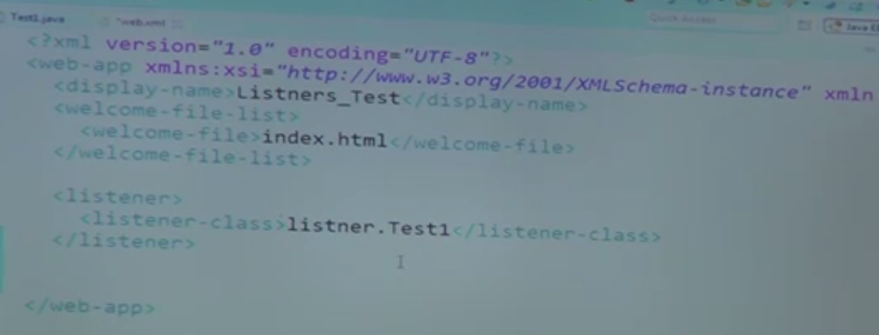
    4. 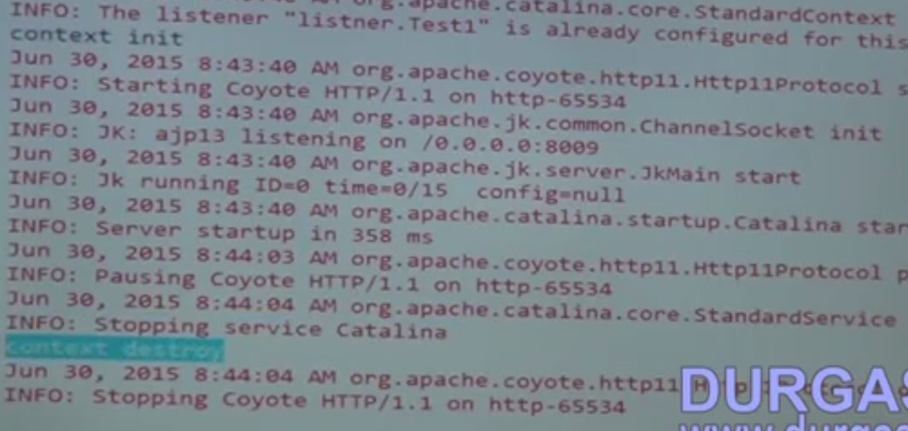
    5. SessionListeners
    6. 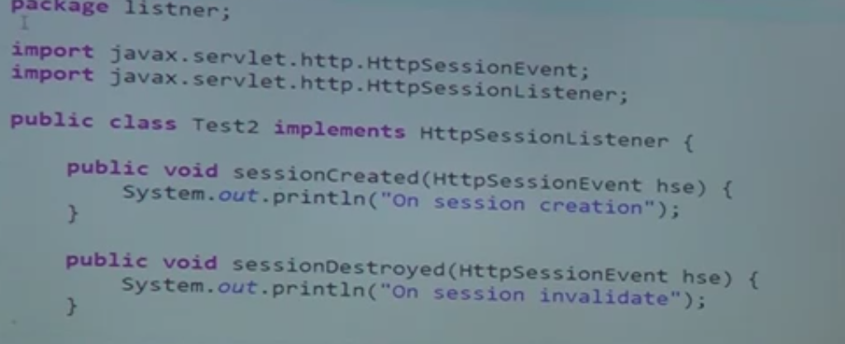
    7. 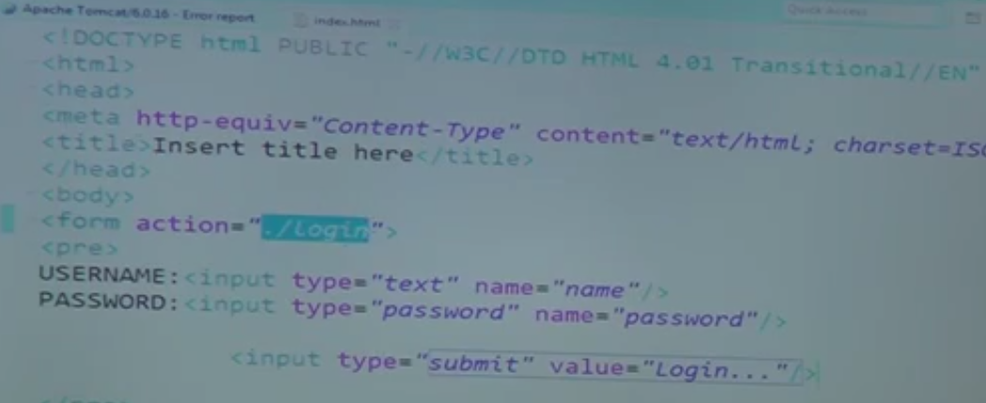
    8. 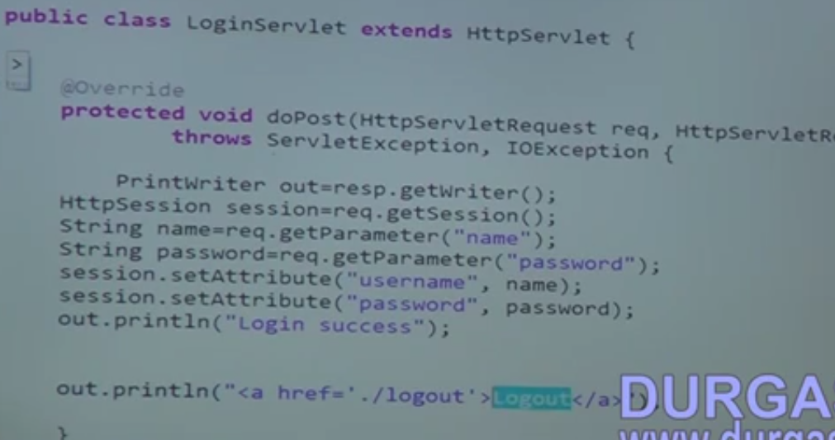
    9. 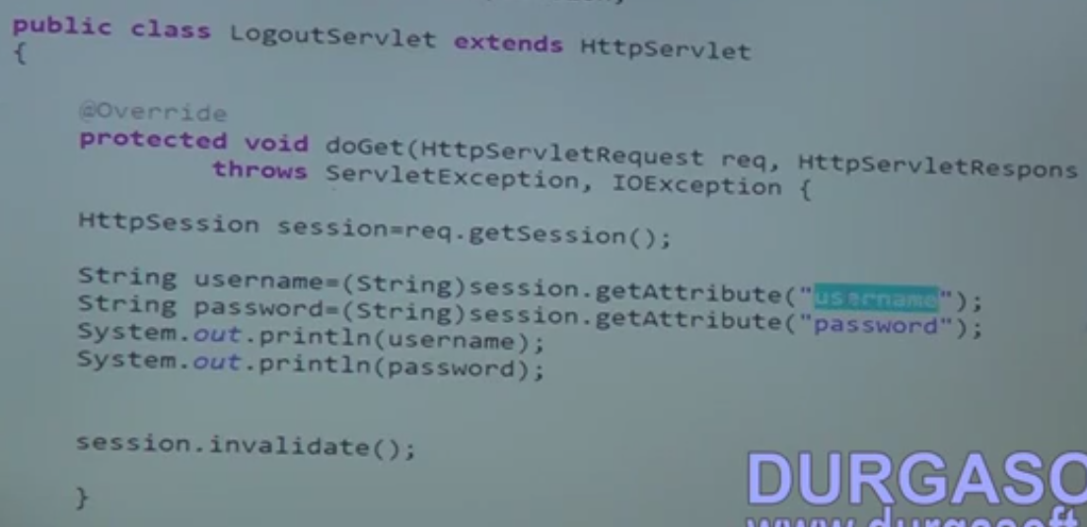
    10. 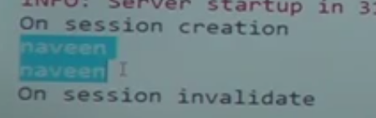
    11. 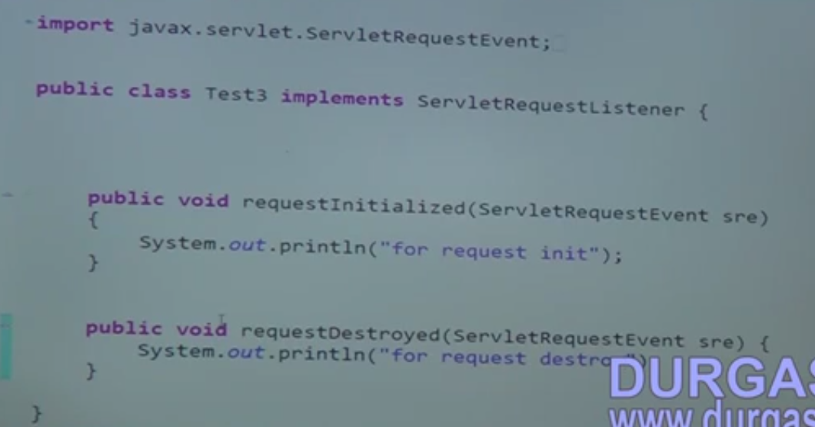
    12. 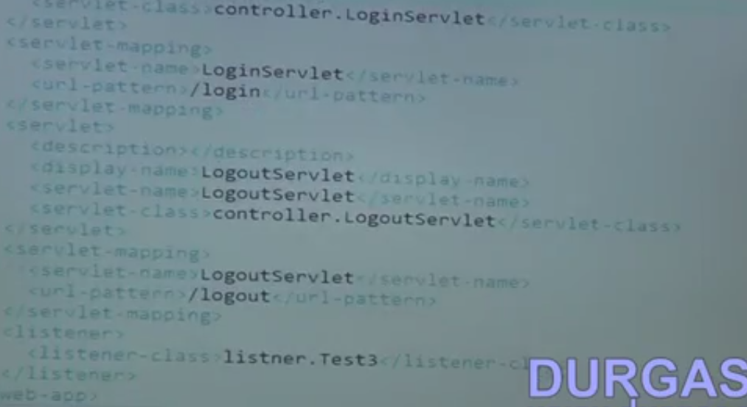
    13. 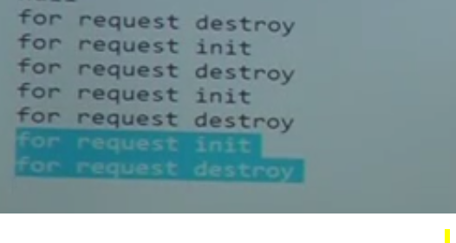
49. 49.Adv Java-JSP-Part 1
    1. Java Server Page
    2. JSP Architecture
50. 50.Adv Java-JSP-Part 2
    1. 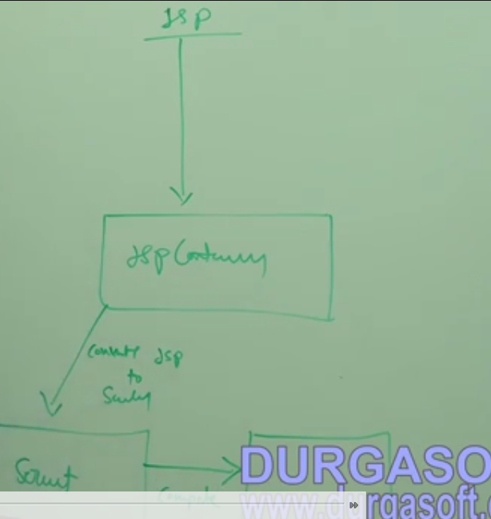
    2. 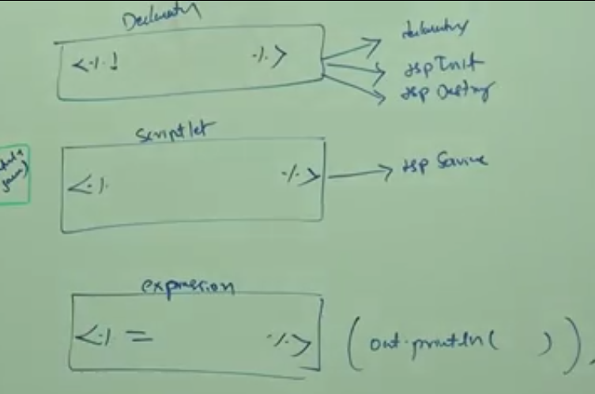
    3. 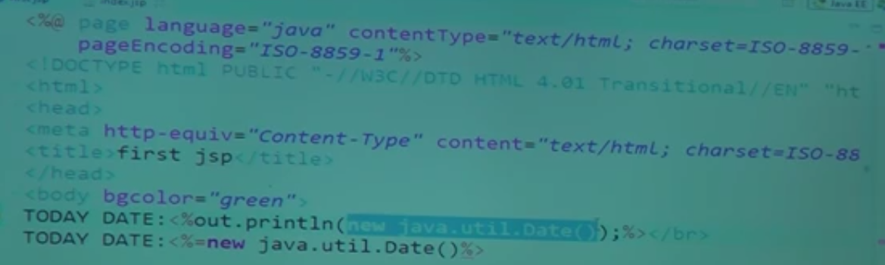
    4. 
    5. 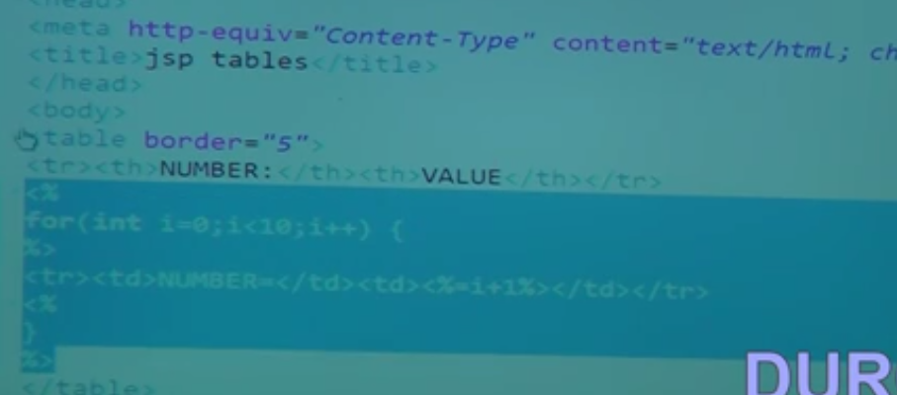
    6. 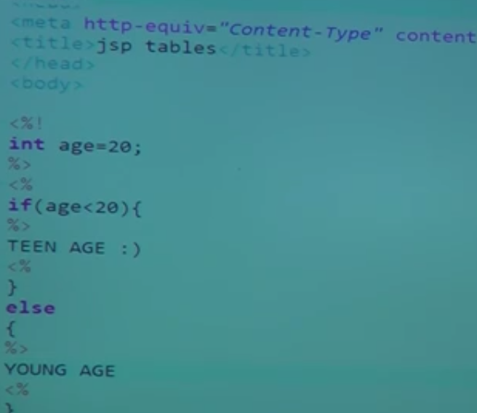
51. 51.Adv Java-JSP-Part 3
    1. 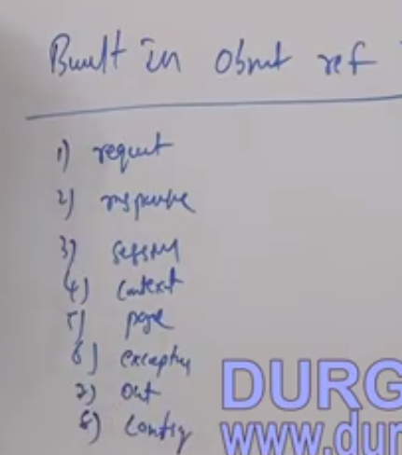
    2. And Page content (Adding to the above)
52. 52.Adv Java-JSP-Part 4
    1. 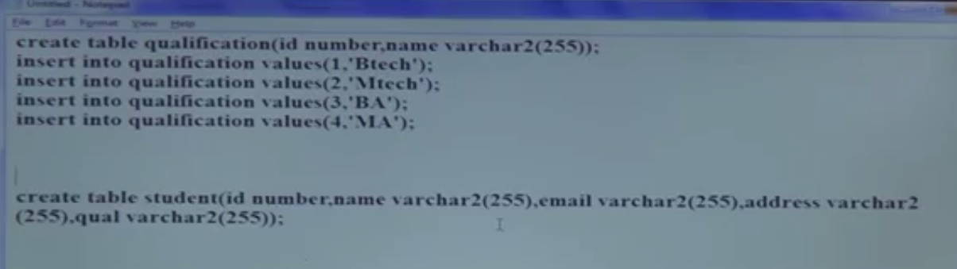
    2. 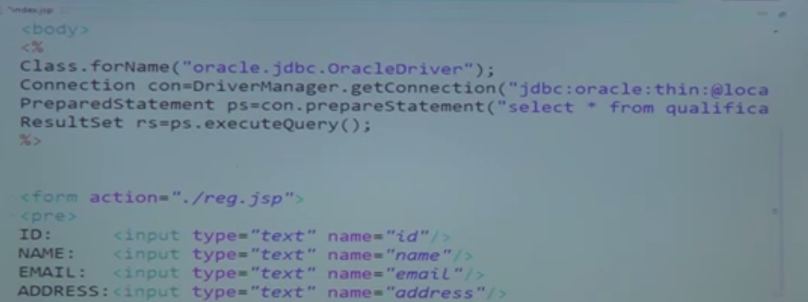
    3. 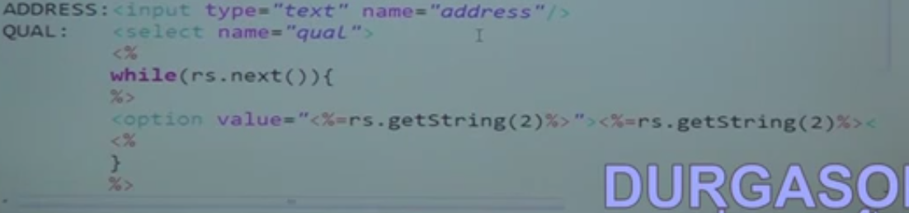
    4. 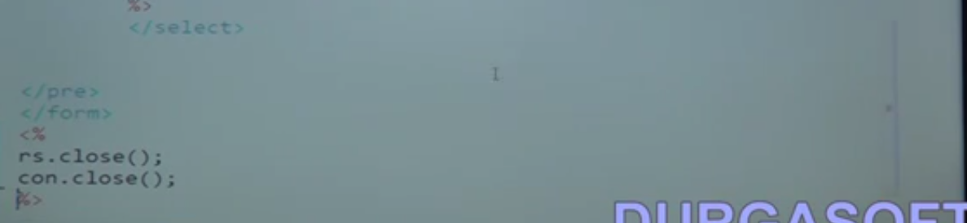
    5. 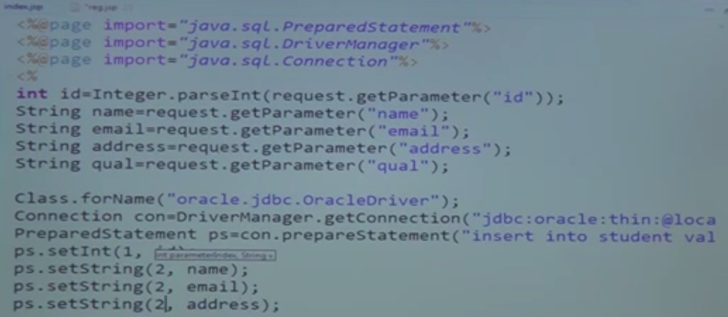
    6. 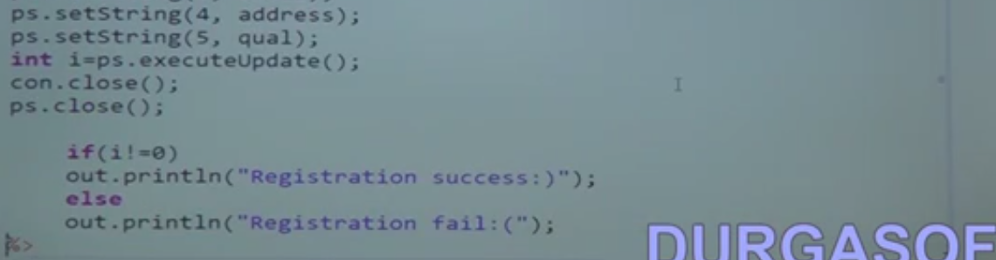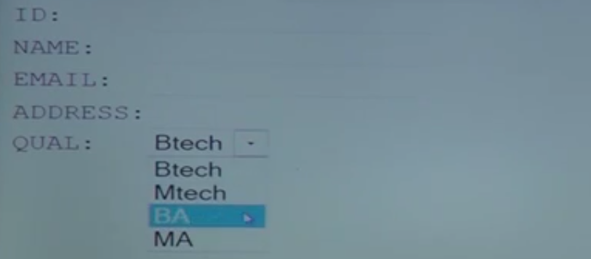
    7. This JSp file when compiled it will place in try?catch. so we need not to worry about exception handling
53. 53.Adv Java-JSP-Part 5
    1. Difference between<jsp:include/> and <@include File/>

|  |  |
| --- | --- |
| <jsp:include/> | <@include File/> |
| It will compile the page every time if the page requested | Compile only on the start up and not on every call |
| Recommended for pages which have a chance of changing | Recommended for pages which do not have a chance of changing |

* 1. 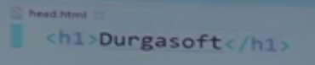
  2. 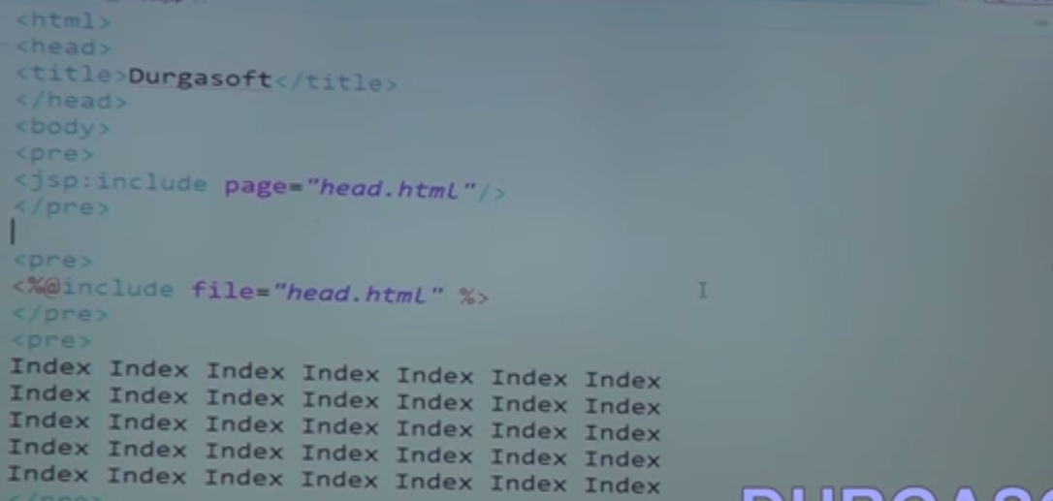
  3. It work on only war file and for JSP file only

1. 54.Adv Java-JSP-Part 6
   1. 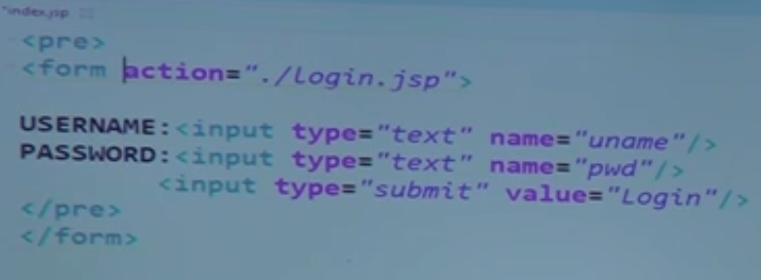
   2. 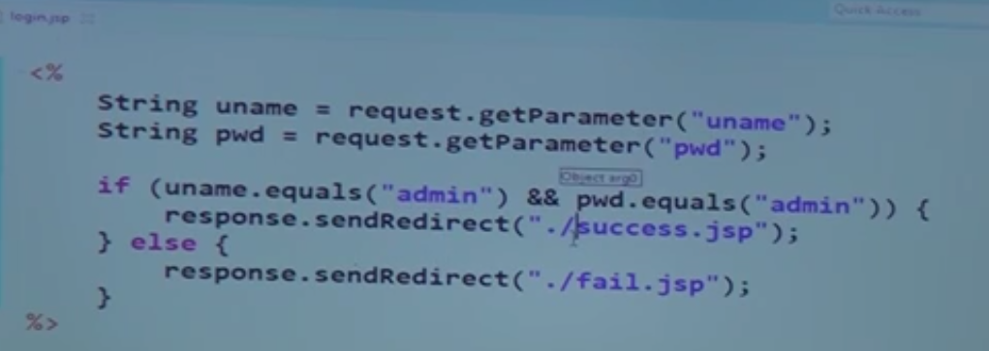
   3. 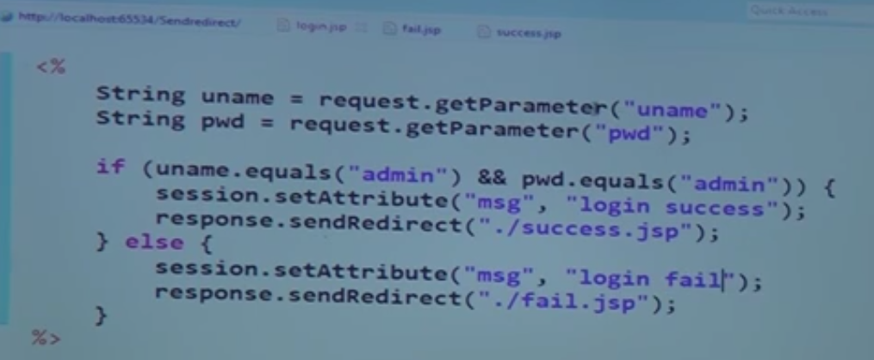
   4. 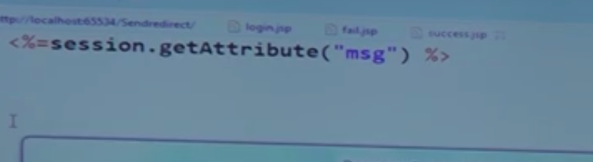

# Cookie Example

1. Introduction
   1. 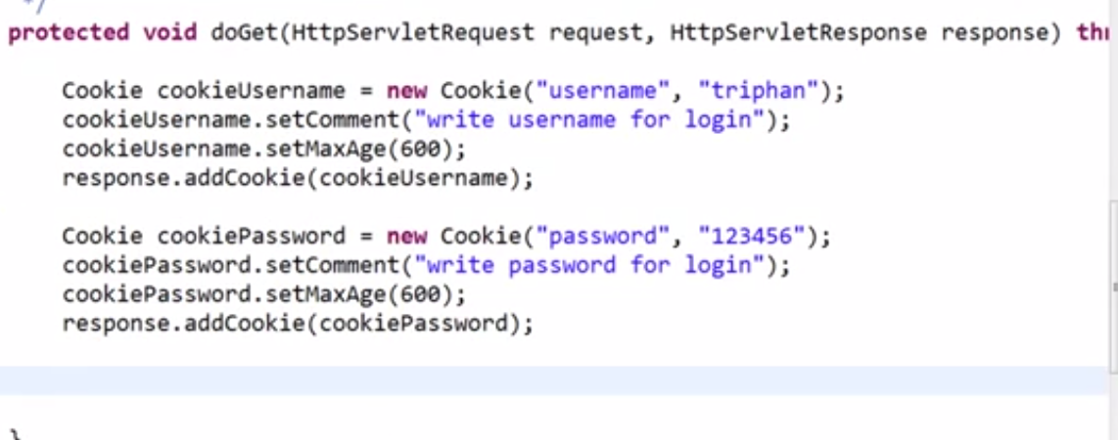
   2. 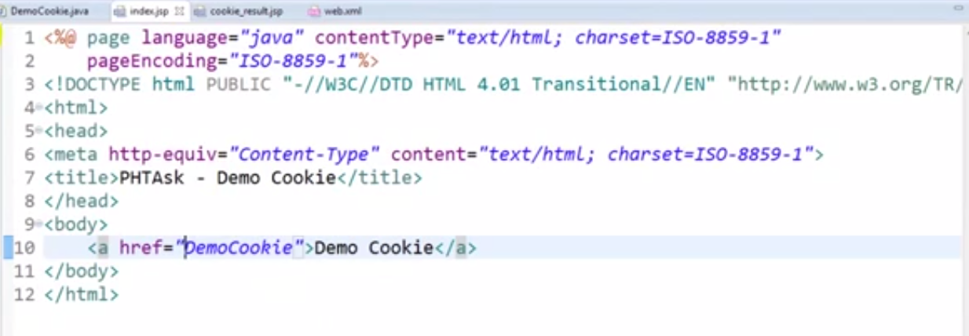
   3. 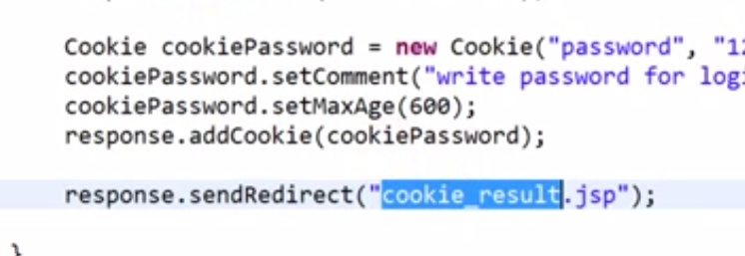
   4. 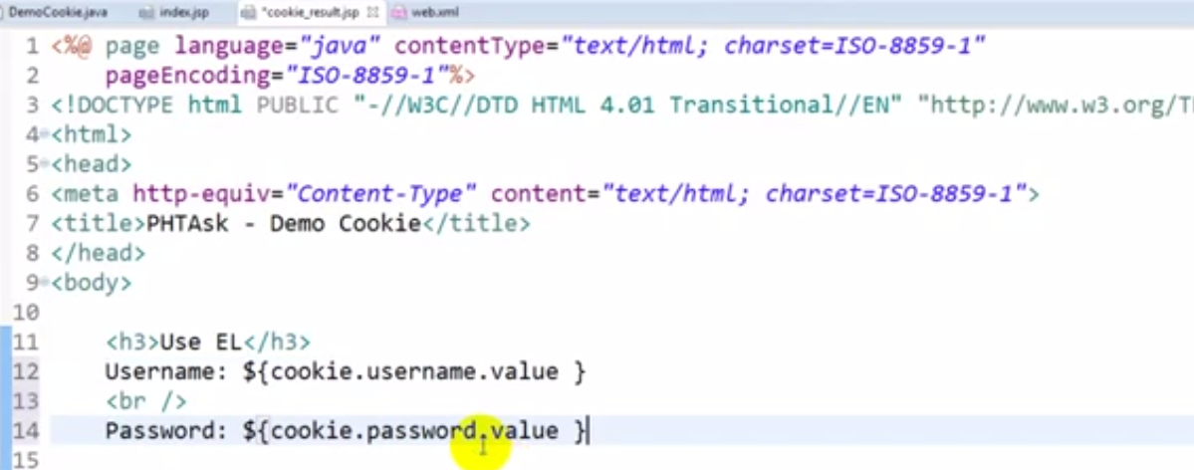
   5. 